

MSc in Computer Science - Team Project

Interim Report

**Group 2 – SafePath App**

*More than Navigation, Smarter, Safer journeys*

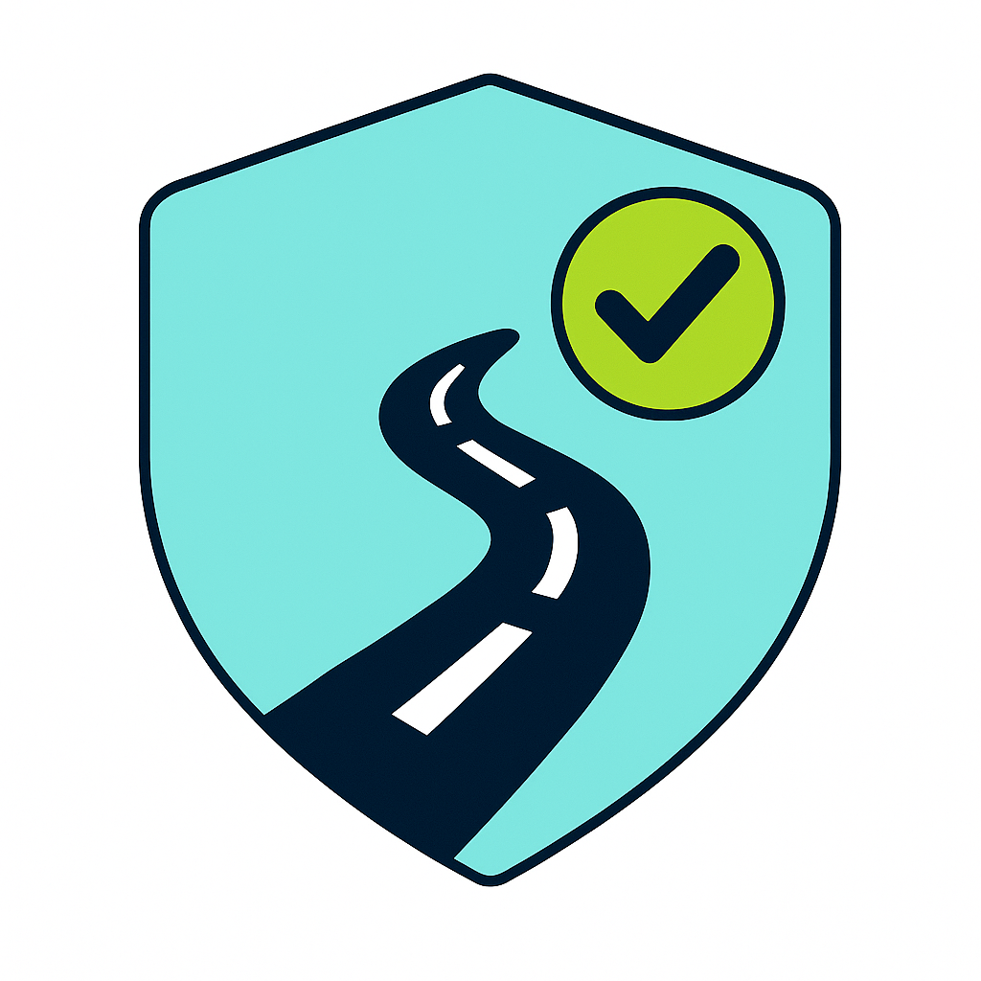

**Team Members**

D24126339 – Huda Ibrahim

D24127853 – Hina Kausar

D24126048 – Shalini Kuruguntla

D24125575 – Sai Priyanka Basa Shanker

D24125555 – Karan Joseph

**23/10/2025**

Table of Contents

1. Introduction 4

2. User Scenario 5

3.1 Identifying the Target Users 5

2.1.1 Personas 5

2.1.2 Collective Insights 8

3.2 Why They Are Important? 8

3. Technical Problem 14

3.1 Core Technical Problem 14

3.1 User Interface and Frontend Experience 19

3.1 Architecture and Deployment 22

4. Data 23

2.1.1 Information 23

2.1.2 Data Resources and Management 23

2.1.3 Cleaning and Pre-Processing Data 24

2.1.4 Data Pipeline and Architecture 25

3.2 Review of Existing Solutions 25

5. Technical Solution 30

Functionality Specification 30

6. Technical Solution - The Plot 33

Front-End Technologies 35

2.2.1 Figure 3.3: *User Interface Mockup: Route Planning Screen* 36

2.2.2 Figure 3.4: *User Interface Mockup: Interactive Map with Routes* 37

2.2.3 Figure 3.5: *User Interface Mockup: Hazard Reporting Interface* 38

2.2.4 Figure 3.6: *User Interface Mockup: Emergency Alert Screen* 38

Back-End Architecture 39

7. Evaluation 40

3.3 Evaluation Methodology 40

2.3.1 Figure 4.1: *User Study Protocol Flowchart* 41

2.3.2 Figure 4.2*: Evaluation Metrics Dashboard Mockup* 42

2.3.3 Figure 4.3: *Route Comparison Example* 42

8. Conclusion 43

Project Management Strategy 43

3.4 Current Challenges 44

3.5 Timeline and Deliverables 45

9. References and Key Resources 47

# **Introduction**

Dataset: [**https://data.police.uk/data/**](https://data.police.uk/data/)

The goal of this project is to make a safety-first navigation app for cyclists and walkers that is easy to use, looks good, and works well. The app was first called "SafetyCyclePath" and then changed to "SafePath" to give it a more modern brand identity. We looked at three different logo ideas for the app: (A) a wordmark with pictures of a cyclist and a walker, (B) a shield with a route and a location pin, and (C) a shield with a road and a checkmark. We also chose the colour scheme for the app. After a short UI survey, users said that (Design C) was the clearest and easiest to remember. We then used it as the final logo and made the app's theme match those colours.

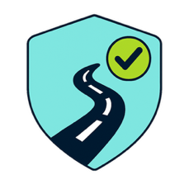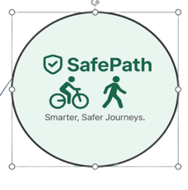

**Figure 1 - Logo C**

**Figure 2 - Logo B**

**Figure 3 - Logo A**

The app has a lot of features, such as routing that takes safety into account (Safest / Balanced / Fastest), the ability to report hazards with pictures, buddy matching for shared trips, and map-first browsing with clear, easy-to-understand safety signs.

The goal of the resulting application is to help Vulnerable Road Users (VRUs) feel less anxious when travelling through cities by making it easier for them to make smart decisions about their safety and route planning. We looked at different navigation tools and used survey data to find out what problems everyday cyclists and pedestrians face. This helped us come up with important user-driven features like visible safety ratings, easy-to-use controls for managing route trade-offs, and clear, believable explanations for suggested routes.

The project uses OpenStreetMap OSM data as a base for its road network data. It also includes several London-specific datasets, such as feeds on roadworks and infrastructure updates, available lighting data, publicly available crime figures, and hazards highlighted by the community. These different types of information are turned into map-aligned attributes like infrastructure quality (like protected bike lanes and pedestrian crossings), lighting coverage, the chance of recent incidents (like roadworks or obstructions), environmental risk factors (like rain or wind), and crime exposure levels that change over time. Along with this, user profiles are made where users provide permission to save their routing preferences, saved routes, frequently visited places, and search history. This lets users personalise their experience by choosing things like well-lit streets, calmer routes, or avoiding busy crossings. Users will be able to select and compare routes and get a clear Safety Score for each segment by combining this data. This will give them a useful way to see how safe a route is under the present conditions. The FindBuddy feature, which is optional, will also assist users find friends who are going the same way at the same time. It does this by matching their locations and schedules in a way that keeps their privacy safe.

The main goal of SafePath is to create an easy-to-use online tool that shows routes and safety overlays clearly on both desktop and mobile devices, lets users report hazards, and gives users preset options for the safest, most balanced, and fastest courses.

The MVP puts a high value on clear data, fast interaction, and safety cues that are easy to understand. This goes beyond what traditional navigation applications do and sets the stage for more advanced features like lighting/crime integration, weather modifiers, and buddy matching in future versions.

# **User Scenario**

## **Identifying the Target Users**

SafePath system was designed with a specific goal in mind: to help people who live in cities and deal with safety issues every day to understand it. We used user research, surveys, and persona development to find key categories of vulnerable road users (VRUs) whose experiences contributed to developing the project's vision. The system is aimed at people who live in cities and rely on walking or biking to go around every day, but who have problems with safety, awareness, and infrastructure. Early UX research and surveys found the following key user groups:

### Personas

SafePath primarily serves pedestrians and cyclists in urban areas, particularly those who rely on walking or cycling as a sustainable and cost-effective means of transportation. Personas assist developers and artists understand the types of individuals for whom they are creating content. You don't just consider a general "user." You consider real persons with real requirements. Within this group, we identified five main user categories:

* **University students** and young commuters frequently walk or cycle to class and come home after dark.
* **Working professionals** looking for a safer daily commute can cycle or walk to neighbouring offices or transportation hubs.
* **International residents** and visitors who are unfamiliar with community safety patterns want credible counsel.
* **Community people** can report problems like poor lighting and hazardous crossings to improve public safety data.
* **City planners and local councils** use aggregated reports to improve infrastructure and public safety measures.

As part of the Explore phase, we created three unique personas based on study results, user survey data, and problems:

**Expert Cyclist – Alex Byrne**

A professional software developer and seasoned biker who prioritises efficiency, fitness, and control. Alex exemplifies the performance-driven yet safety-conscious commuter who frequently cycles to work and utilises digital tools to track progress.

* **Goals:** include improving cycling performance, designing safe routes, and reducing reliance on cars.
* **Wants and Needs:** Safe and efficient routes, weather-aware maps, and real-time warnings for accidents and hazards.
* **Pain points** include poor bike lane lighting, imprecise map data, and risky road crossings.

SafePath assists Alex by providing data-driven route ideas, real-time rerouting, and safety heatmaps to enable confident and informed decision-making.

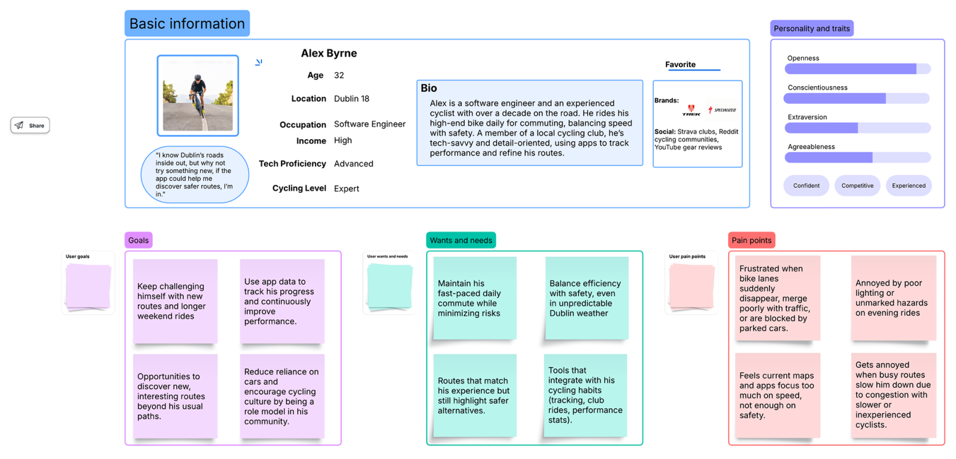

Figure 4 - Persona – Expert Cyclist

**Daily Walker – Eliza Chen**

A retired art curator who takes daily walks for fitness and community connection. Eliza symbolises the active older user who prioritises simplicity, safety, and social belonging.   
**Goals:** Daily walks promote physical and mental well-being, social connection, and safe exploration of the community.   
**Wants and needs** include well-lit walking pathways, easy navigation for low-vision persons, and a simple, intuitive design.   
**Pain points** include poor lighting, difficult route interfaces, and worry over secluded regions.   
SafePath provides Eliza with route visualisations, real-time safety alerts, and easily accessible interface settings (bigger icons, simple layout, high contrast).

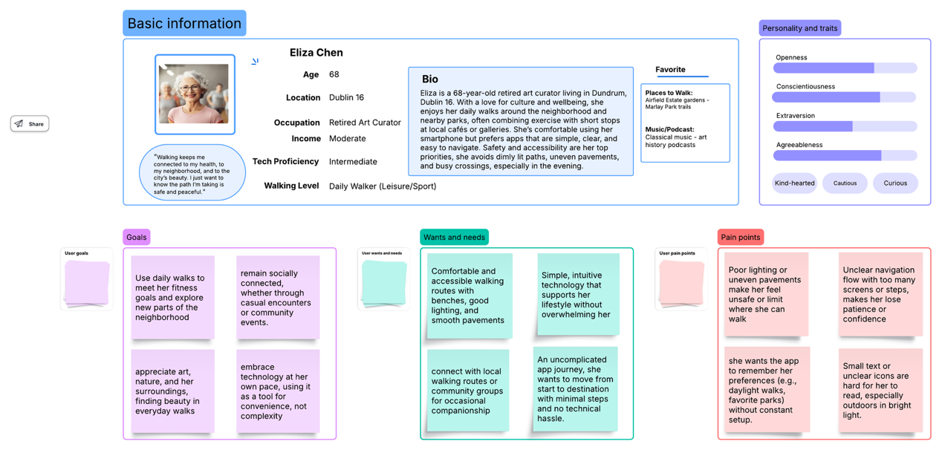

Figure 5- Persona – Daily Walker

**Wheelchair Pedestrian – Daniel Murphy**

A library assistant and wheelchair user who values accessibility, freedom, and seamless travel experiences. Daniel symbolises users who have limited physical mobility in typical route planners.

* **Goals:** Use technology to plan accessible and efficient journeys while maintaining confidence and autonomy during travel.
* **Wants and Needs:** Accurate data on curb heights, ramps, and crossings, a smooth app experience, and consistent accessibility upgrades.
* **Pain points** include incomplete accessibility data, insufficient path surface mapping, and a lack of inclusive design in current navigation apps.   
  SafePath offers Daniel accessible route options, audio advice, and community feedback tools for reporting inaccessible places.

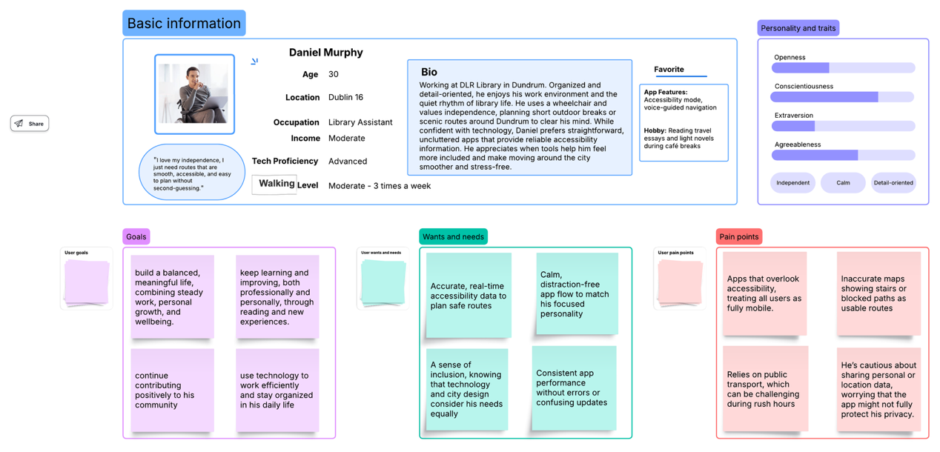

Figure 6 - Persona – Wheelchair Pedestrian

### **Collective Insights**

Analysing all three identities, Alex, Eliza, and Daniel, reveals that, despite their disparate lifestyles and abilities, they share several basic needs and expectations. When selecting routes, all users emphasise personal safety and reliability over speed, demonstrating a strong preference for safety-first navigation. Each user prioritises clarity and accessibility in the app's design, which includes readable maps, clear visual cues, and straightforward interactions that reduce confusion while travelling. Another common discovery is the value of community participation; users are motivated to give hazard reports or comments when they see how their contributions improve collective safety. The addition of the "Find a Mate" feature promotes users' desire for social connection and reassurance, especially when travelling at night or in unknown locations. Finally, all personas highlight the importance of reliable, data-driven recommendations—they want a system that appears intelligent, responsive, and credible in offering route options that accurately represent real-world safety situations. These findings support SafePath's objective to build an inclusive, user-centred platform that caters to a variety of needs while encouraging safety, awareness, and confidence in urban mobility.

## Why They Are Important?

These users represent the growing number of people who prefer active, environmentally friendly ways of transportation. While walking and cycling promote sustainability and health, many people avoid them due to perceived or actual risks. Every day, we face unsafe crossings, poorly lit streets, high-crime neighbourhoods, and a lack of riding lanes. SafePath's focus on this diverse, yet safety-conscious demographic directly promotes the aims of urban safety, inclusion, and environmental sustainability.

**UX Research and Surveys**

User survey and data collected by the team revealed that **75 % of respondents preferred safe routes over fast ones**, and **73 % were willing to report hazards**.

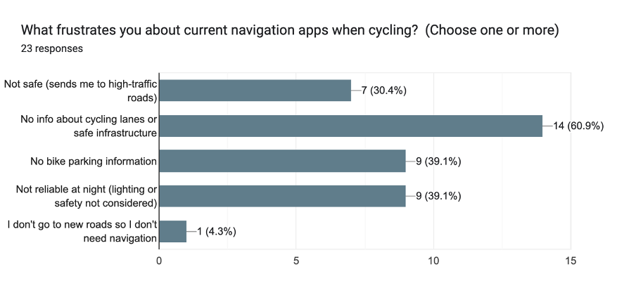

Figure 7- Frustrations about Current Apps

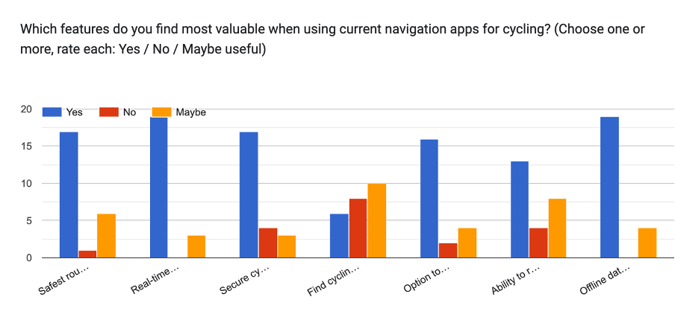

Figure 8 - Valuable Navigation Apps Features

**Key Findings:**

* 91% are beginners or intermediate riders → focus on ease and confidence.
* Top frustrations:
  + Lack of info on cycle lanes/safe infrastructure (61%)
  + Missing bike parking and night safety features (~39%)
* Desired features: real-time hazard alerts, secure parking, and offline data.
* 75% prefer safest routes over fastest.
* 96% would use cycle parking finder.
* 75% open to connecting with others if privacy is protected.

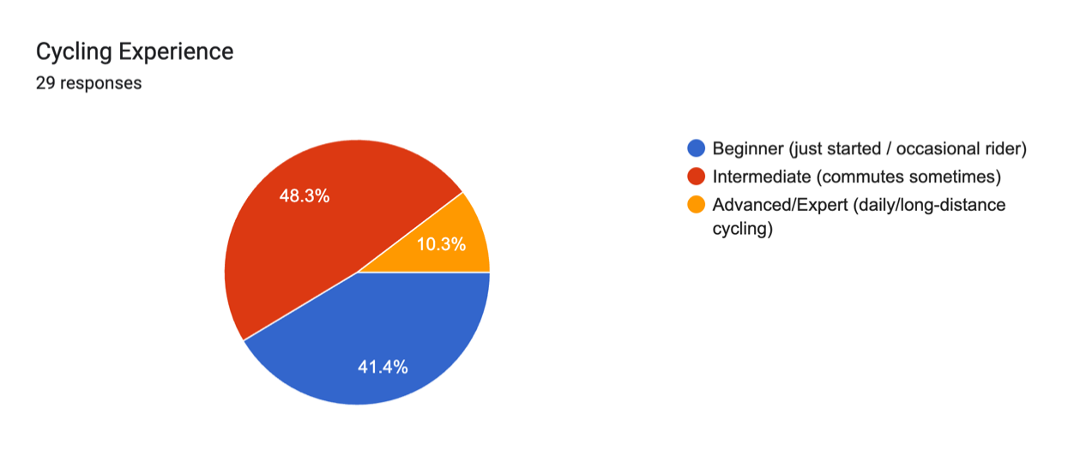

Figure 9- Cycling Experience

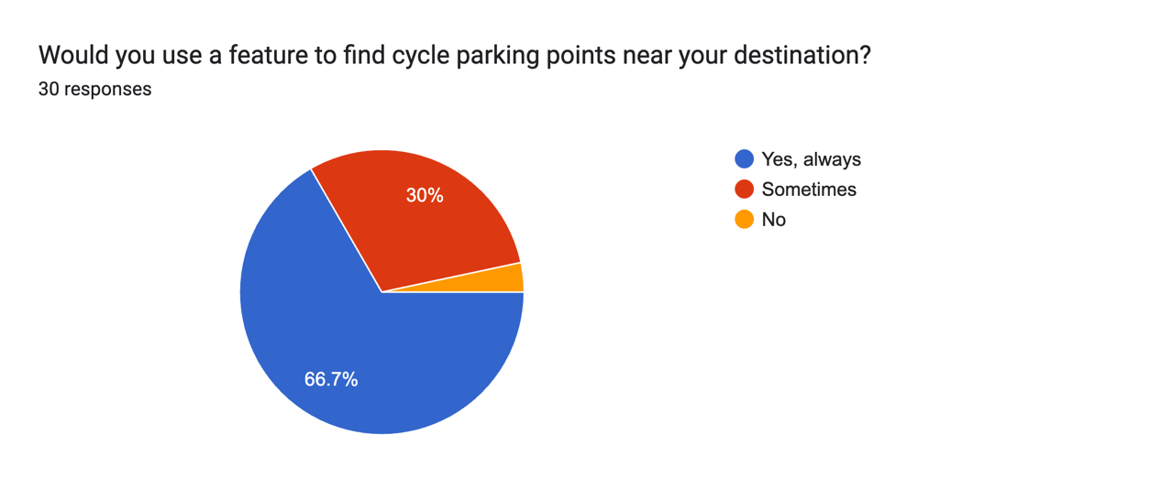

Figure 10 - Pike Park Feature

**Pedestrian Insights (48 responses)**

* Main Takeaways:
* 61% walk daily; walking is part of routine mobility.
* Top frustrations:
  + No hazard alerts (50%), poor lighting info (45%), and lack of safety awareness (39%).
* Most valuable SafePath features:
  + Safe routes (61%)
  + Real-time safety alerts (61%)
  + Safer crossings (50%)
* 85% prefer safe or context-based routes over fastest.
* 100% open to real-time alerts (with smart control).
* 75% open to connecting with walking groups (if privacy protected).
* 73% willing to report hazards, supporting community-driven safety.

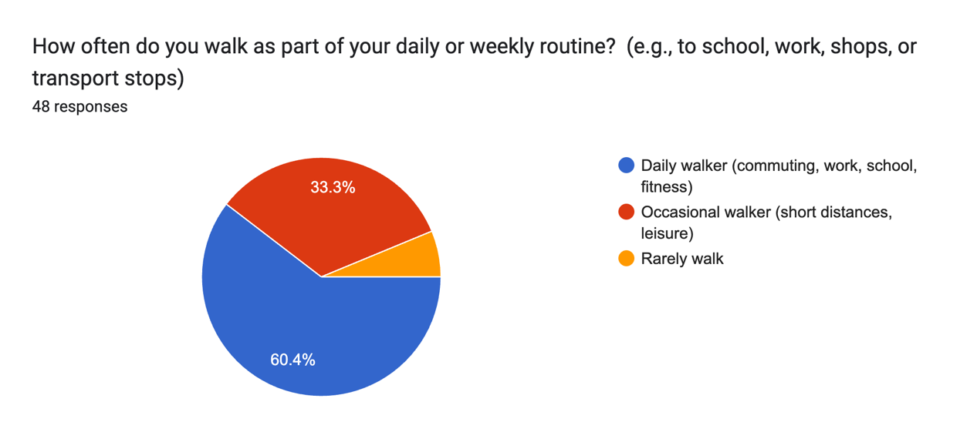

Figure 11- Walking Experience

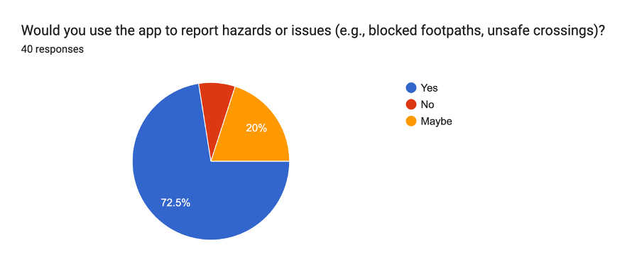

Figure 12 - Reports Hazard Feature

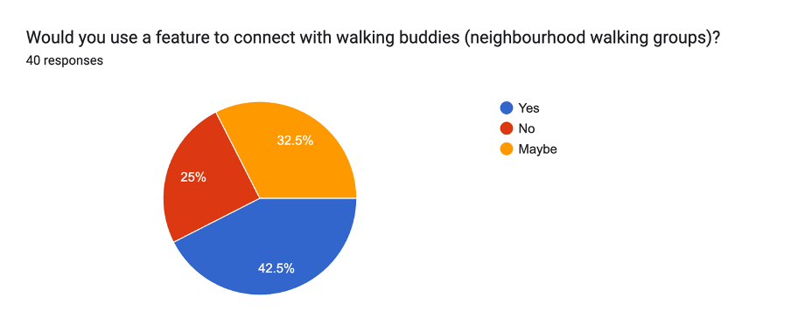

Figure 13 - Find buddy Feature

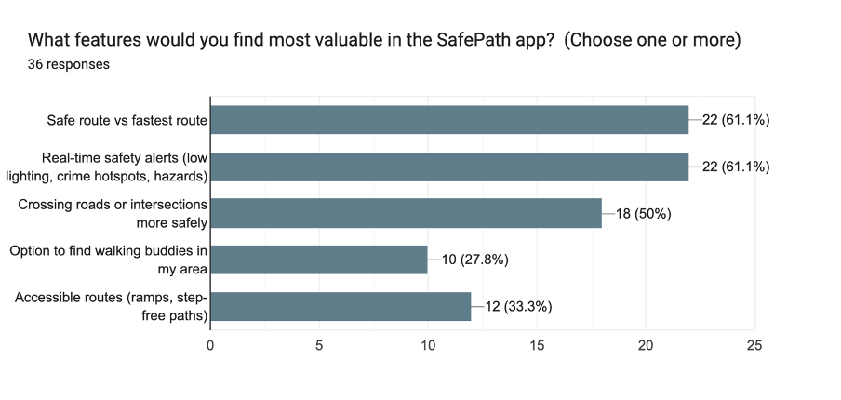

Figure 14 - User Most Valuable Features

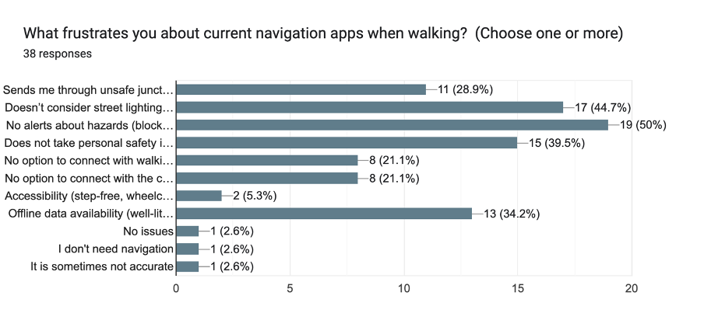

Figure 15 - Current Navigation Apps Experience

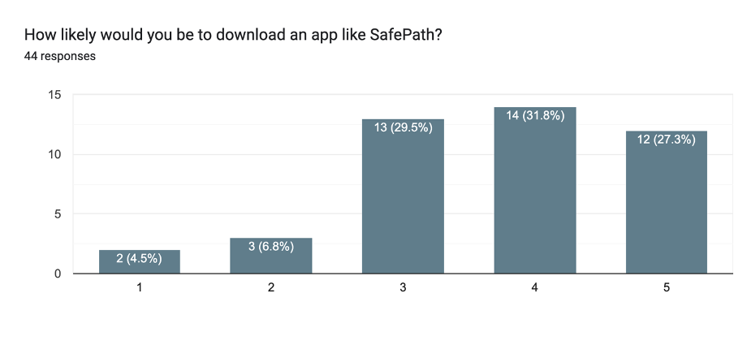

Figure 16 - User Interest in App Download

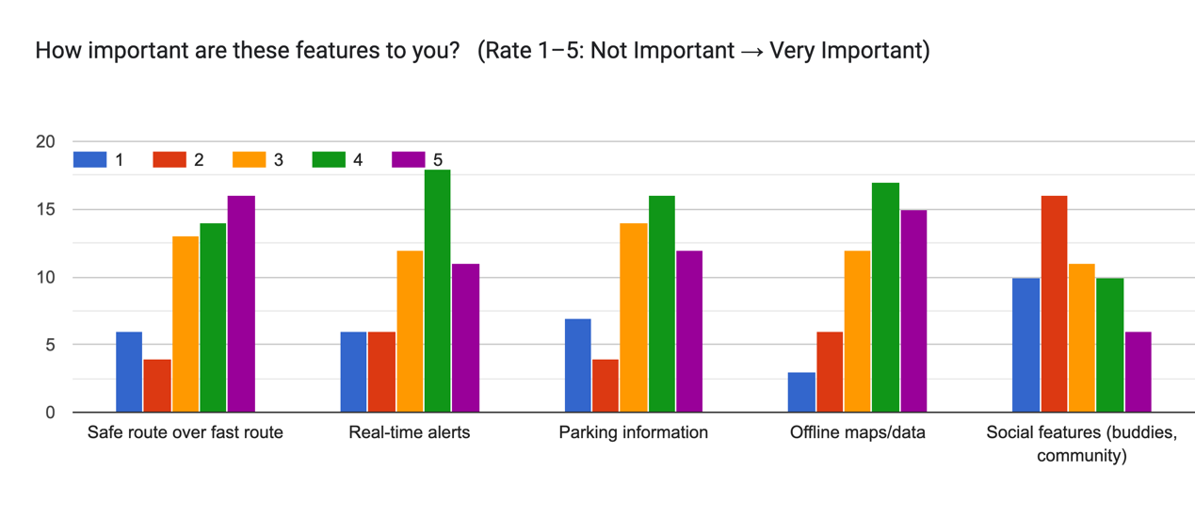

Figure 17 - App Features Importance Diagram

* **Main Takeaways:**
* Preferred **alert type:** non-intrusive — 41% only when app is open, 34% push notifications.
* Most important features: **Safe routes, real-time alerts, offline maps**.
* **59% likely or very likely** to download SafePath; **90% positive or neutral** overall.
* Encouraging factors:
  + **Free to use (82%)**
  + **Unique safety features (52%)**
  + **Trust from local councils or universities (32%)**
* Awareness channels:
  + **Social media (59%)** and **friends’ recommendations (55%)** are key.

These findings confirm strong user motivation for a system that values safety and community participation.

Current navigation apps, such as Google Maps, Waze, and Strava, focus on time and distance rather than safety. They fail to consider real-world facts such as criminal density, lighting quality, and accident frequency. As a result, even the quickest path may expose a pedestrian to hazardous conditions.   
SafePath fills this void by aggregating several datasets—crime, infrastructure, lighting, weather, and user reports—and assigning a Safety Index to each route segment. Users can evaluate the fastest and safest routes and choose based on their comfort and context. The system also promotes friendship with a "Find a Mate" feature that matches users with comparable routes and schedules, improving both physical and psychological safety.

# **Technical Problem**

## Core Technical Problem

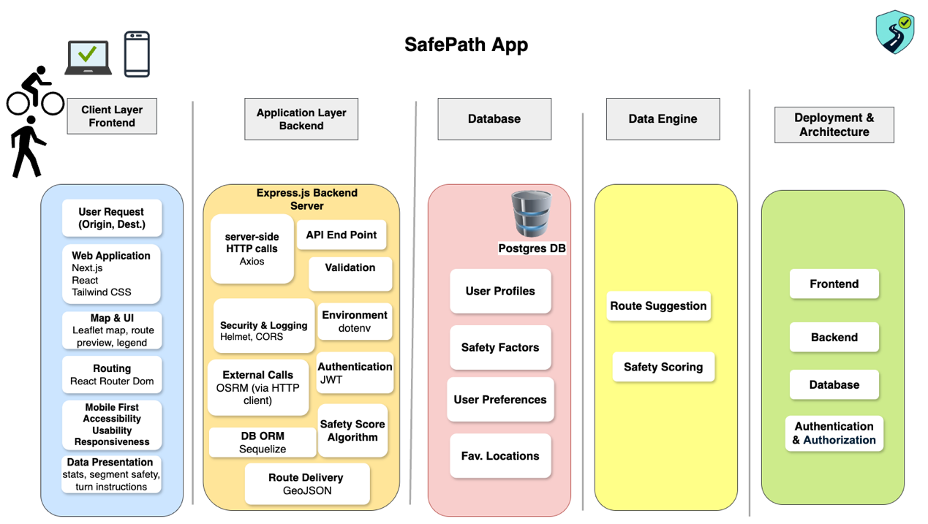

Figure 18 -Technical Component Diagram

The idea for this app went through multiple iterations before the current format was finalised. Starting from discovering suitable datasets for urban mobility, first for pedestrians, then for cyclists. We iterated on feasibility and coverage and ultimately combined both to serve mixed-mode users. The concept of a safety-first routing application, SafePath combining hazard-aware navigation with an optional buddy feature was chosen for a variety of reasons.

SafePath covers a common gap we found in our competitive analysis with the help of this app comparison article(Portus, 2024). It says that most navigation tools, even those made for cycling, only focus on time or distance, with little thought given to personal safety (for example, they only have "quiet" or surface-type filters). This means that people who walk and ride bikes have to figure out how to stay safe on their own instead of using evidence-based risk models. This disparity is essential since the environment and infrastructure have a clear effect on how likely it is that bikers and pedestrians may get hurt. For instance, having protected or separated facilities, well-designed streets, and enough light all make people less likely to get hurt and more likely to walk or cycle (Reynolds et al., 2009)(Teschke et al., 2012)(Vidal-Tortosa & Lovelace, 2024).

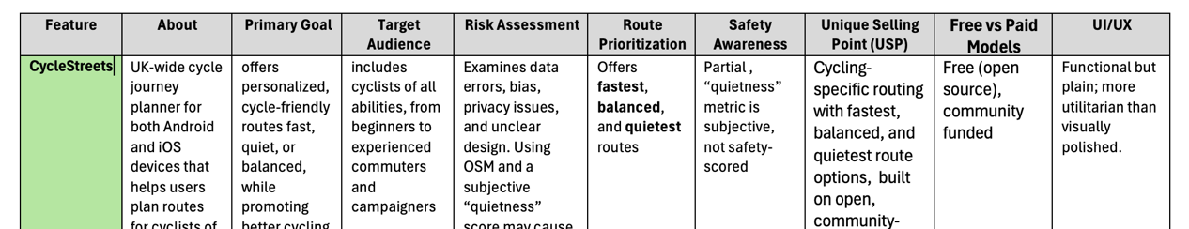

Figure 19 - Competitive Analysis Sample

Our user research supports this reason. The interview guide focusses on the interface's readability, the user's perception of safety, and their expectations for features like "Find Buddy." These are exactly the areas where current services don't do enough for vulnerable road users (VRUs). The survey was given to students, engineers, healthcare workers, teachers, and other people in the community. This shows that there is a lot of interest in safe, everyday cycling beyond just sport riders.

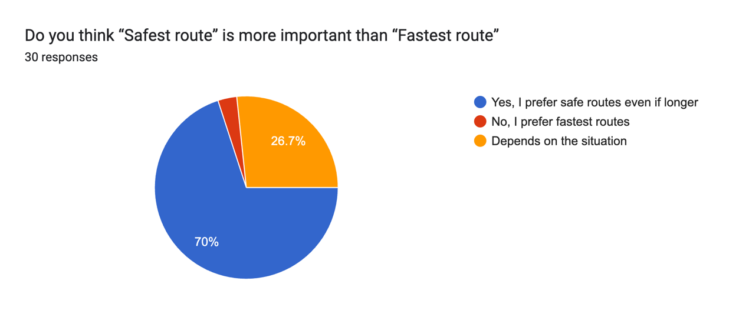

Figure 20- Safest vs Fastest

Research indicates that "near misses" are common and provide insights into risk, yet are never included in official datasets; crowdsourced reporting can address this gap(Nelson et al., 2015)(Branion-Calles et al., 2017). Adding community hazard reports to official feeds is not simply a nice-to-have feature; it is critical for safe routing.

Finally, safety situations change all the time. Patterns in the weather, visibility, and time of day change the level of danger; for example, rain, low visibility, and peaks all raise the risk of a crash, and changes in the weather change the number of cyclists and the chance of an accident(Myhrmann & Mabit, 2023)(Pazdan, 2020). A static "fastest route" model can't deal with these changing exposures; SafePath's purpose is to do so.

* 1. **Core Technical Challenges**

The core technical challenge tackled by Safepath is the merging and unification of diverse safety data sources into one routing framework capable of producing individual, safety-optimized routes for both pedestrians and cyclists. This challenge has a number of closely linked technical difficulties. The first one relates to the combining of various data sources such as crime statistics from data.police.uk with more than 10 million yearly records from 43 police departments, infrastructure quality data from the National Cycle Network covering over 12,000 miles of cycling routes, traffic accident data from the STATS19 reporting system, and real-time user-reported hazards, which leads to substantial data engineering challenges (Novack et al., 2024).

**Figure 2.1:** *System Architecture Overview Diagram*

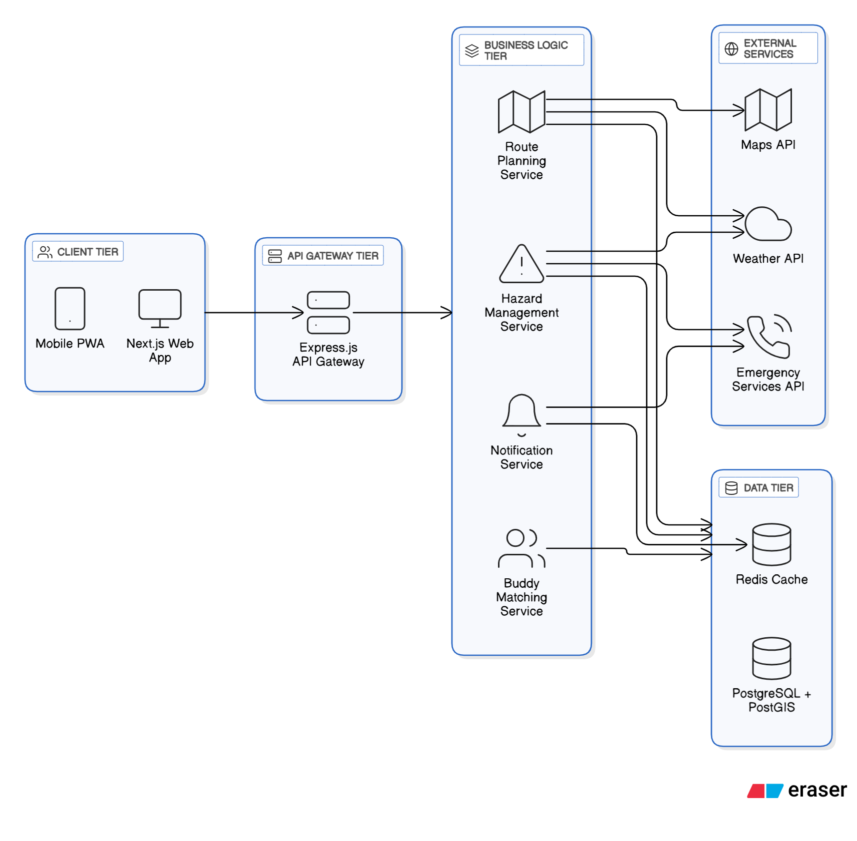

Multi-tier architecture illustrating the Safepath system components and data flow. Arrows indicate communication between layers, with external services providing supplementary data for route optimization and safety assessment.

Secondly, the system must confront the difficulty of spatial-temporal crime risk modeling, which implies the necessity to use kernel density estimation techniques for the finding out of crime hotspots and for the consideration of the temporal patterns like day-night variations and seasonal movements (Kang & Kang, 2017). Thirdly, the system has to come up with a composite safety scoring algorithm that would be capable of weight and merging the different risk factors into one metric that would represent the giving urban routes' complex safety profile (Al-Omari et al., 2025). Research by Kapousizis et al. (2021) reveals that the use of segregated cycling facilities leads to a significant reduction of 65% in injury risk compared to mixed traffic conditions. hence, confirming the pivotal role of infrastructure quality in safety calculations.

1. **Figure 2.2:** *Comparison Matrix of Existing Navigation Systems*

|  |  |  |  |  |  |
| --- | --- | --- | --- | --- | --- |
| **Feature** | **Google Maps** | **Apple Maps** | **Komoot** | **Strava** | **Safepath** |
| Crime Data Integration | ❌ | ❌ | ❌ | ❌ | ✅ |
| Infrastructure Quality | ⚬ | ⚬ | ⚬ | ⚬ | ✅ |
| Collision Risk Analysis | ❌ | ❌ | ❌ | ❌ | ✅ |
| User-Reported Hazards | ⚬ | ❌ | ⚬ | ⚬ | ✅ |
| Personalization | ⚬ | ⚬ | ✅ | ✅ | ✅ |
| Real-time Safety Updates | ❌ | ❌ | ❌ | ❌ | ✅ |

***Note.*** ✅ = Full support; ⚬ = Partial/limited support; ❌ = Not supported. Safepath provides comprehensive safety features absent in existing navigation systems.

Finally, the technical difficulty lies in the fact that traditional pathfinding algorithms such as A* are to be modified in such a way that the safety scores are considered as edge weights but at the same time real-time route calculation efficiency is not compromised (Delling et al., 2017). As a result, the A* algorithm has to be reworked in a way that the safety of the route is optimized according to the user preferences and at the same time the route is made as efficient as possible hence there would be different settings for the risk tolerance. According to Zhang et al. (2019), the graph deep learning techniques can simultaneously capture spatial and temporal dependencies and hence, are able to outperform the traditional methods by 15-20% in accuracy thus making the approach technically justified.

**Figure 2.3:** *Data Integration Challenge Flowchart*

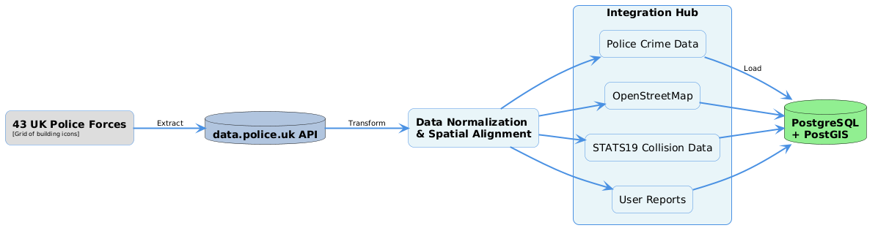Data integration pipeline showing the flow from multiple disparate sources to unified storage. The normalization layer ensures spatial and temporal consistency across heterogeneous datasets

## **User Interface and Frontend Experience**

Figure 3.3: User Interface Mockup: Route Planning Screen

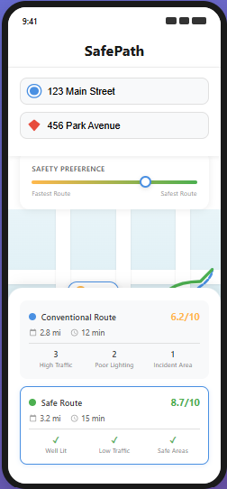

Route planning interface allowing users to input destinations and configure safety preferences. The slider enables personalization of the safety-efficiency trade-off based on individual risk tolerance.

Figure 3.4: User Interface Mockup: Interactive Map with Routes

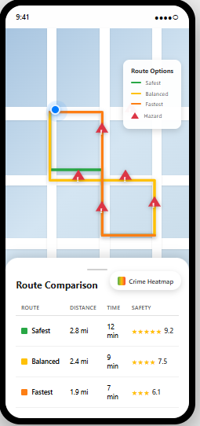

 Interactive map interface displaying multiple route alternatives with visual safety indicators. Hazard markers show real-time reported issues, and the comparison table enables informed decision-making.

Figure 3.5: User Interface Mockup: Hazard Reporting Interface

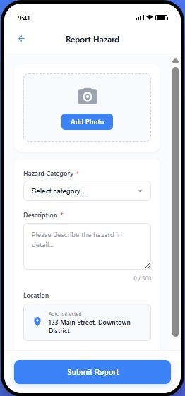

Hazard reporting interface will make users to contribute real-time safety information. Photo upload, categorization, and severity rating ensure structured data collection for system-wide safety assessments.

Figure 3.6: User Interface Mockup: Emergency Alert Screen

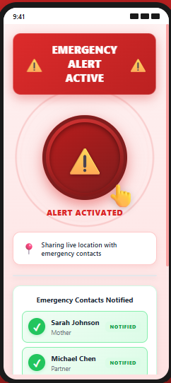

Emergency alert interface prioritizing rapid access to emergency services. Live location sharing and automatic contact notification provide critical safety features for vulnerable road users in distress.

## **Architecture and Deployment**

The back-end architecture includes a microservices-based system that is deployed on a highly available clustered infrastructure with load balancing. The API gateway is built using Express.js and it consists of authentication middleware, request validation, and rate limiting in its structure. The business logic is spread across different services according to their specialization, such as a Route Planning Service that performs pathfinding algorithms and safety score calculations, a Hazard Management Service that verifies and processes user reports, a Buddy Matching Service that manages location-based pairing requests, and a Notification Service that oversees push notifications, emails, and SMS alerts (Kumar et al., 2024). All these microservices are talking to each other via internal APIs and event-driven architecture, and Redis is utilized as a cache layer for active sessions storage and often accesses route data.

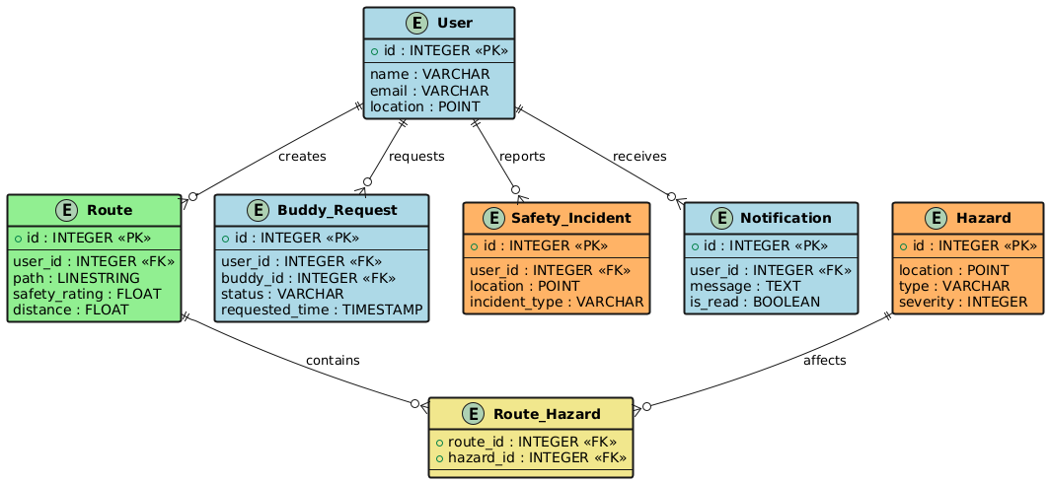

Figure 21 - Database Entity-Relationship Diagram

Note. Database schema using crow's foot notation to illustrate relationships. PostGIS geometry fields enable spatial queries for proximity analysis and route calculation.

# **Data**

### Information

The SafePath app uses data from many different sources to make a complete and smart system that can give cyclists and pedestrians safe-first routing. The system's strength is that it can dynamically analyse route safety by merging official available datasets with data from the environment and the community. SafePath changes how people see and interact with their urban environments by combining real-world data on crime, illumination, infrastructure, and environmental elements.

### Data Resources and Management

A solid integration pipeline gathers data resources from various sources. Crime data is taken from data.police.uk by way of bulk CSV downloads for historical records ranging from September 2022 to August 2025, including all 43 UK police forces (UK Police, 2025). Infrastructure data is sourced through API integration from the National Cycle Network and OpenStreetMap, whilst traffic collision data is acquired from the STATS19 reporting system (Wang et al., 2016). All data goes through a normalization process and is stored in a PostgreSQL database with PostGIS extension for spatial queries, thereby allowing efficient proximity analysis and route calculations (Zhang et al., 2019).

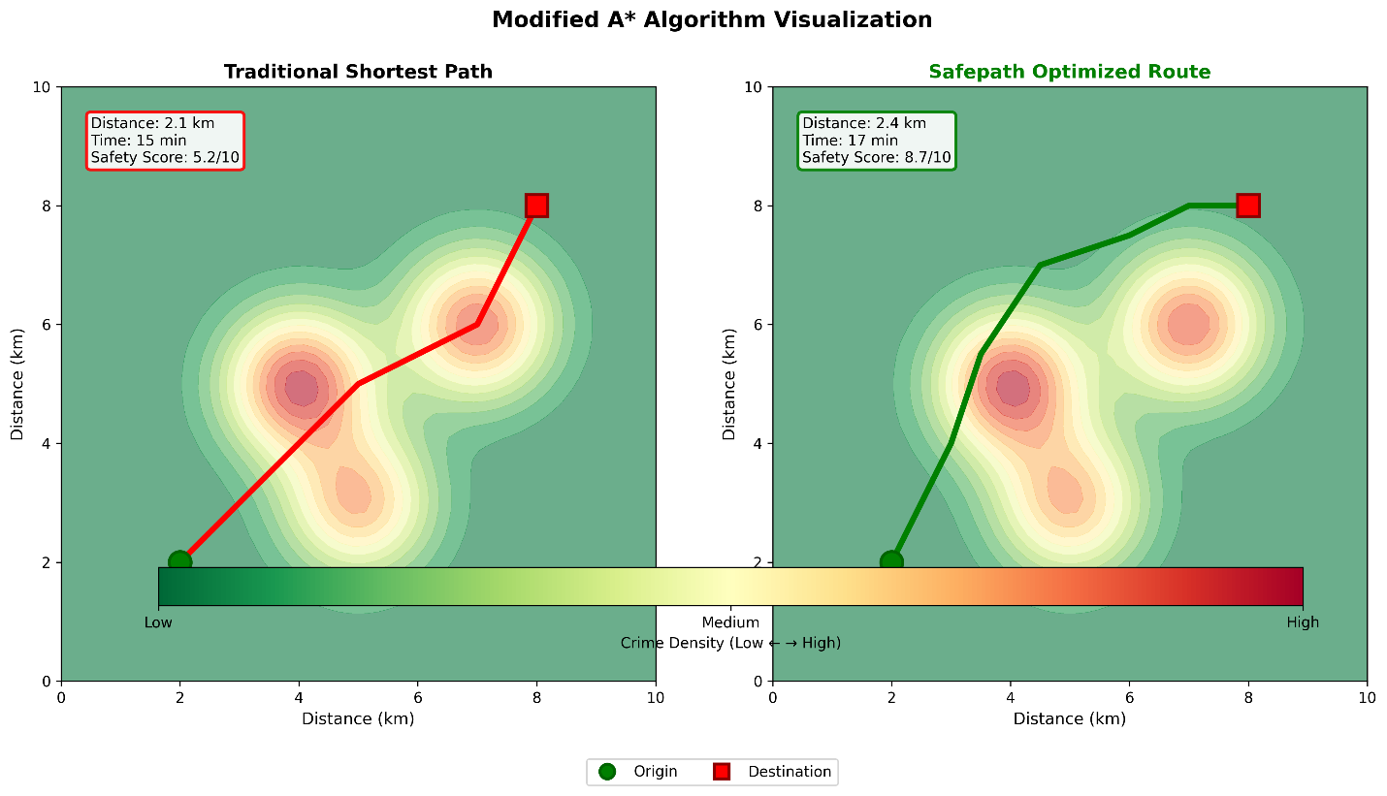

Figure 21- Modified A Algorithm Visualization

Note. Comparison illustrating the difference between distance-optimized and safety-optimized routing. The Safepath algorithm accepts a 14% distance increase to achieve a 67% safety score improvement.

### Cleaning and Pre-Processing Data

SafePath's analytical methodology is built on the Metropolitan Police crime dataset. The original set of 36 raw monthly CSV files had mistaken in them. They were cleaned and changed using Python (pandas, NumPy, GeoPandas) using a ten-step process detailed in the "Crime Data Cleaning Process for London Safety Analysis."  
  
There were 41,238 duplicates (1.68%) and 2.4% of the locations were wrong. The titles of the columns were changed to all lowercase letters. There are now 14 primary classes of crimes instead of 37. For example, Violence_Sexual, Antisocial_Behavior, and Vehicle_Crime. This made the classifications more consistent by more than 60%.  
  
The dates were changed to Python datetime objects, and an exponential decay algorithm (−days/180) was used to give recent offences more weight in the safety rankings. SafePath's Safety Index is based on the severity, frequency, and recency of crimes. Crimes were also given severity weights (0.8–3.0) based on how serious they seemed.  
  
Spatial validation showed that all points were inside London's bounding box (51.28°–51.70°N, 0.51°–0.33°E). If coordinates were unavailable, they were either filled in or marked "Location Withheld."

After cleaning, 95.76% of the data (2,349,666 records over 4,761 LSOAs) was kept. The completed dataset was saved in a PostgreSQL/PostGIS database as a UTF-8 CSV file so that it could be easily analysed and visualised in space.

### Data Pipeline and Architecture

The data pipeline which the system uses consists of pandas for normalization and transformation, plus automated scripts that download, process and update the datasets monthly to keep the data fresh (Novack et al., 2024). User data such as preferences, route history, and reported hazards is stored in the same database with the necessary privacy protection and anonymization procedures. Crowdsourced safety data has been found by Telima et al. (2023) to have 72% agreement with official police statistics, thus supporting the validity of user-generated safety reports that are part of the system.

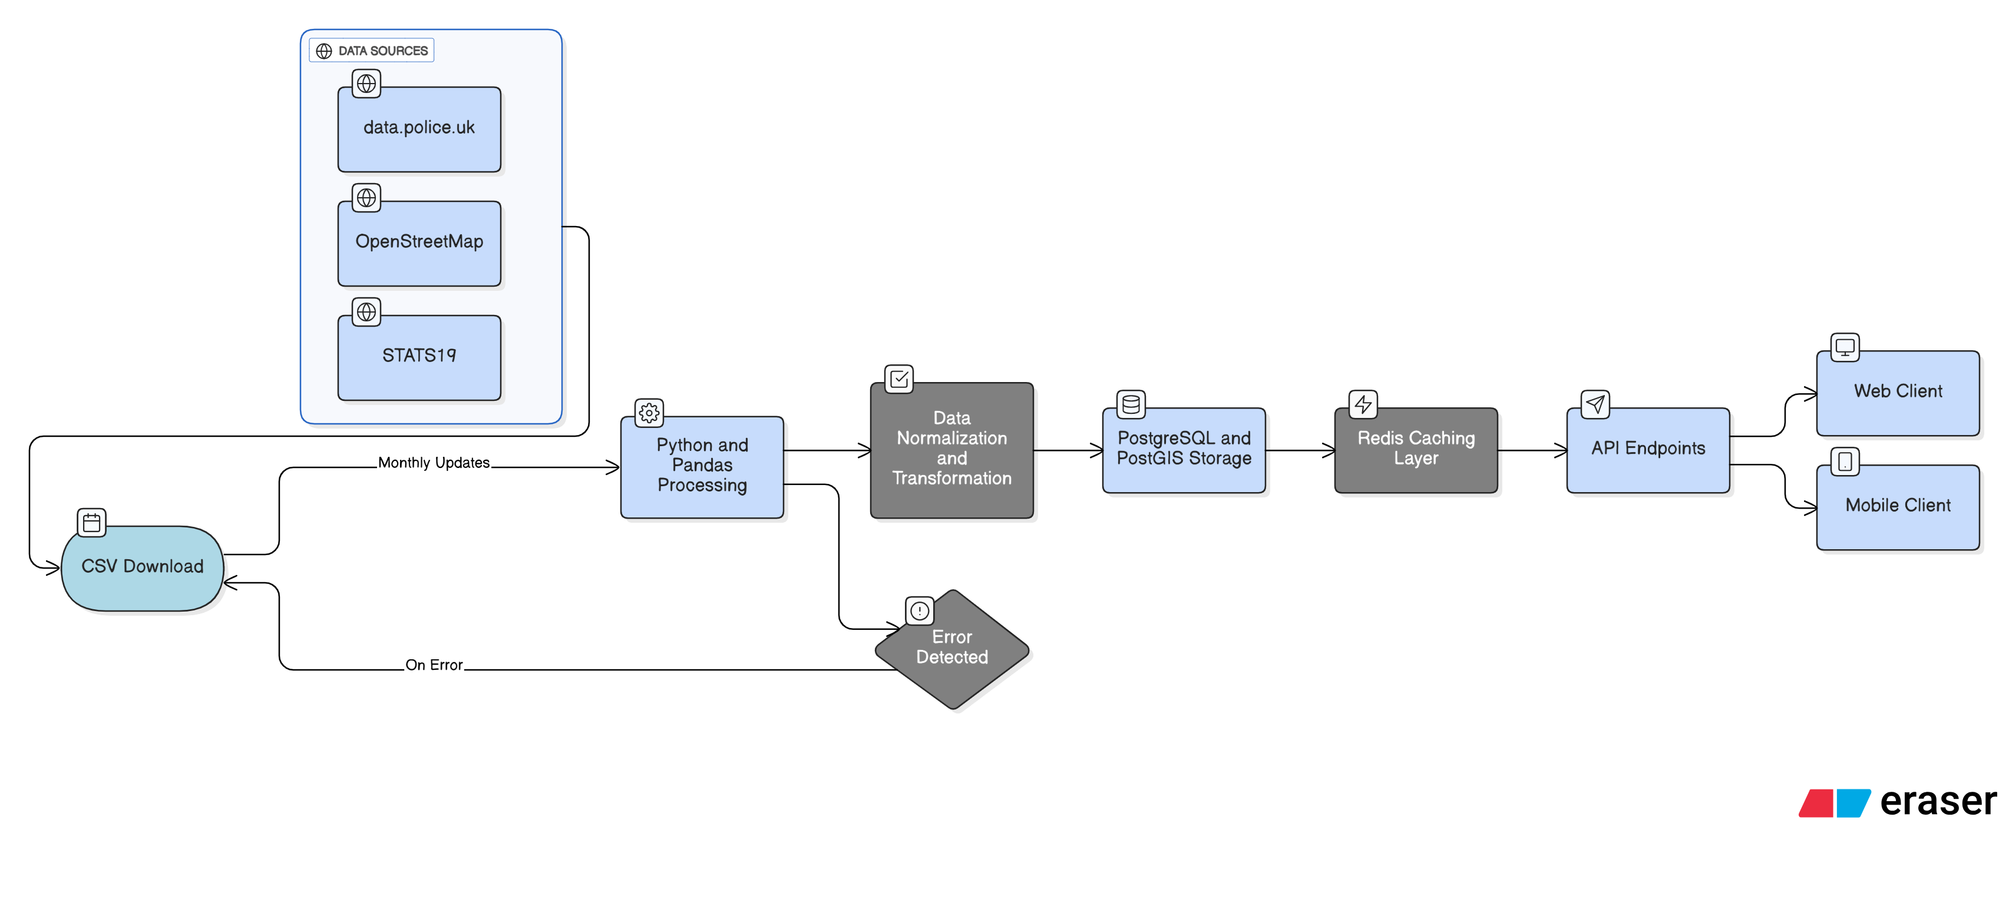

Figure 22 - Data Pipeline Architecture

*Note. Automated data pipeline ensuring monthly updates from multiple sources. Error handling mechanisms maintain data quality and consistency throughout the ETL process.*

## **Review of Existing Solutions**

We looked at other navigation apps to see how the industry works now and to find areas where SafePath may help. The assessment looked at three main platforms: Google Maps, Strava, and Citymapper. These are all popular for getting around cities, but they don't do a good job of integrating safety-aware routing. We looked at how well each system worked, how easy it was to use, how accessible it was, and how well it met the needs of vulnerable road users (VRUs).

**Google Maps**  
  
Google Maps is the most used navigation system in the world. It lets you find your way by car, bike, or foot. Its merits include its precise maps, satellite images, and ability to work with real-time traffic and transit data. But its routing system mostly works to find the fastest and shortest route, not the safest one. The recommendations may put users in dangerous situations because they don't take into account things like illumination, crime statistics, or how comfortable pedestrians are.  
Google Maps is still mostly a utility, even if it has certain accessibility features like showing wheelchair-accessible routes. According to feedback from people who took SafePath's survey, users often felt insecure following routes through poorly lit or remote places, even though they seemed to work well. Also, Google Maps' hazard reporting is centred on cars and doesn't let pedestrians or cyclists report safety issues like broken pavements or dangerous intersections.

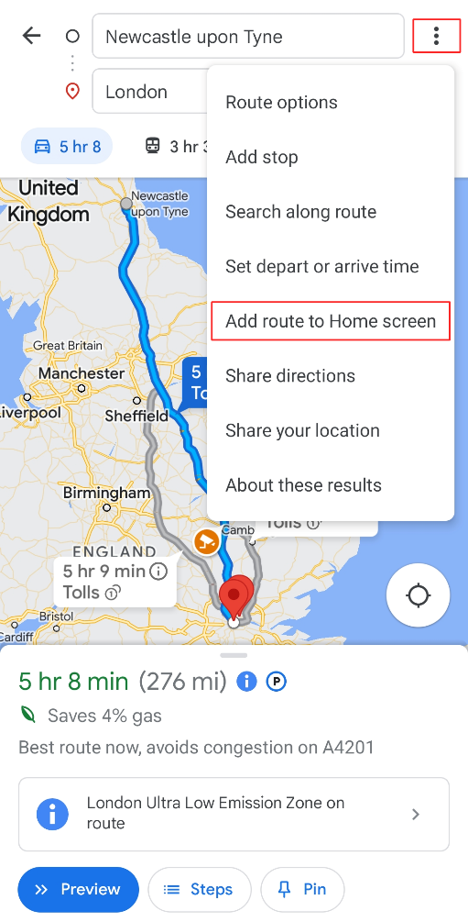

Figure 23 - Google Maps Routing Interface

**Strava**

Starva is a social fitness network that enables users to track and share their athletic activities. It provides tools for analysing performance and connecting with other athletes.  
Strava is a social fitness application designed primarily for athletes and recreational cyclists. This system visualises routes utilising user-generated data, fostering community competition through performance metrics including speed, distance, and elevation. Strava's "heatmap" feature displays commonly utilised paths, yet it inadvertently prioritises routes based on frequency of use rather than safety considerations.  
Regular commuters and casual cyclists may develop a misleading perception of safety; busy routes do not inherently guarantee safety, particularly in urban areas characterised by mixed traffic or insufficient cycling infrastructure. Strava does not integrate with municipal datasets, including crime reports and lighting networks. Additionally, its emphasis on gamification, including segments and leaderboards, contrasts with the safety-first philosophy that underlies SafePath.Strava's design, while leveraging community strengths, presupposes a degree of confidence and capability that may alienate novice users or individuals with a primary focus on security. SafePath aims to modify the participatory ethos of Strava, focussing on safety awareness and collective wellbeing instead of competition.

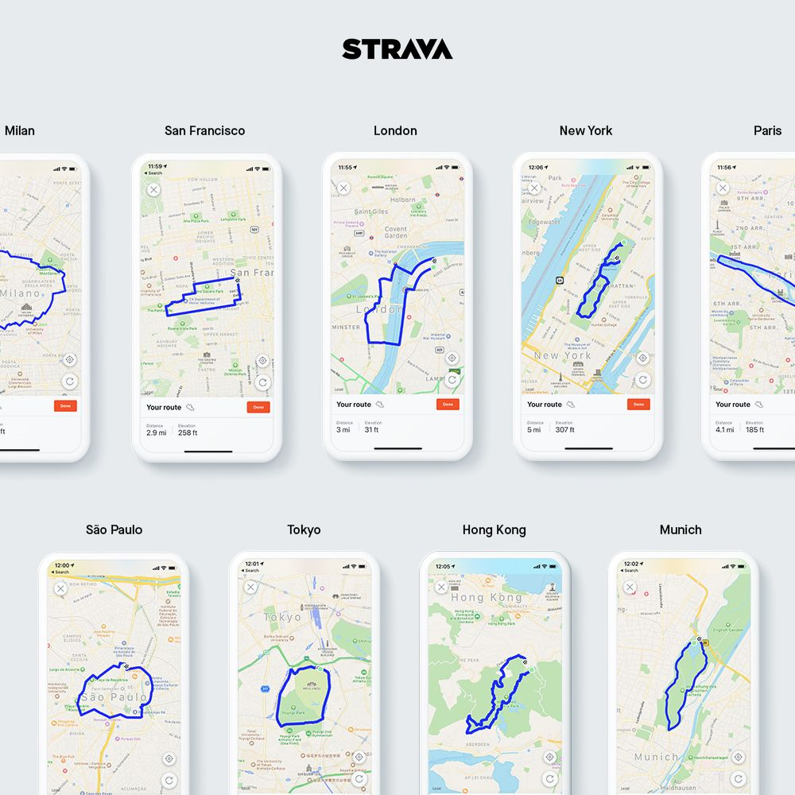

Figure 24 - Example of Strava Heatmap Displ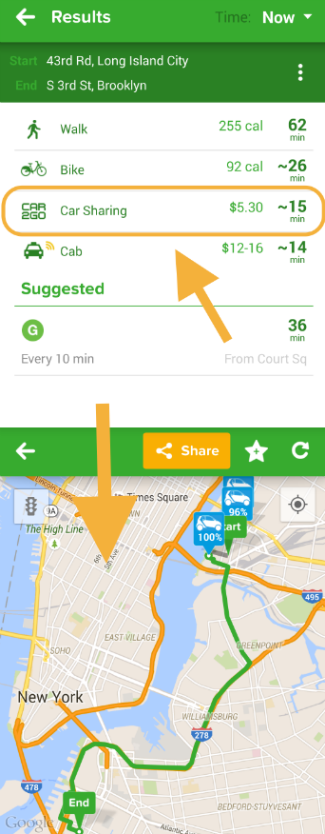

Figure 25 - Citymapper Interface

**Citymapper**

Citymapper offers comprehensive multimodal transport routing in major urban areas, including London. The system consolidates data from public transport authorities, providing alternatives for walking, cycling, bus, and train travel. The user interface is clear and data-rich, contributing to its popularity among urban commuters. Citymapper’s algorithm, like that of Google Maps, does not incorporate contextual safety considerations. It does not incorporate local crime statistics or consider environmental factors, including lighting and weather conditions.  
Citymapper effectively displays estimated costs, CO₂ emissions, and travel times; however, it does not provide any assessment of personal safety or perceived risk associated with the proposed routes. The increasing public concern regarding urban safety highlights the limitations of the platform for pedestrians and cyclists navigating at night or in unfamiliar neighbourhoods.

**Overview and Comparative Examination**  
  
All examined systems exhibit shared functionalities, including real-time routing, integration of multi-modal transport, and map-based interaction. Nonetheless, they collectively exhibit a deficiency in the contextual intelligence necessary to ensure user safety during navigation.  
  
**System: Strengths and Limitations**

Google Maps Comprehensive coverage, real-time traffic updates, accessibility options Emphasises efficiency over safety, exhibits limited hazard reporting, and demonstrates insufficient awareness during nighttime conditions.  
Strava is a social network for athletes, primarily focused on running and cycling activities. It allows users to track their workouts, share their performance, and connect with others in the fitness community. Robust community functionalities and immediate performance metrics Designed for athletes; lacks crime and lighting integration; offers limited inclusivity.  
Citymapper Effective multimodal integration and an intuitive interface Absence of safety parameters in route generation; restricted data personalisation.  
SafePath distinguishes itself by integrating safety-aware intelligence into route planning. This system uniquely integrates live crime data, lighting information, and community hazard reports, offering users three distinct routing modes: Safest, Balanced, and Fastest. This enables users to make informed decisions that correspond with their comfort levels, environmental conditions, and time limitations.  
SafePath enhances community engagement via its reporting feature, which invites users to submit safety observations that improve the collective dataset. This method converts passive navigation into an interactive, citizen-driven safety network, a feature lacking in all existing systems examined.

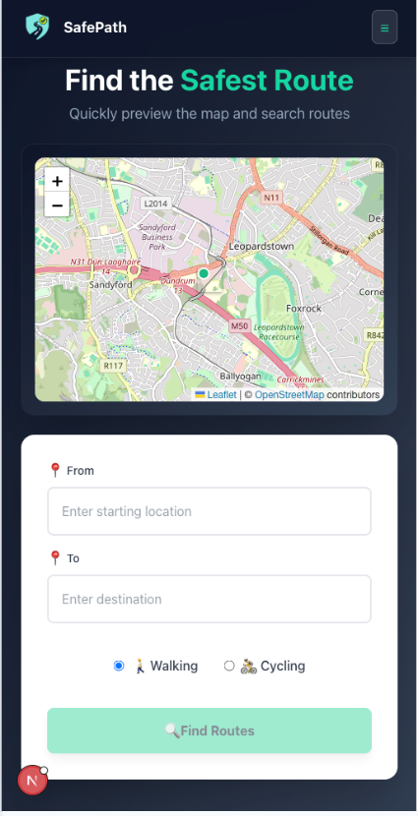

Figure 26 - Comparative Overview – SafePath vs Existing Navigation

# **Technical Solution**

SafePath is intended to be more than just regular navigation systems by directly addressing safety issues that users have brought up for pedestrians and cyclists. SafePath not only helps you find your way, but it also includes standard travel features like origin/destination search, route preview, saved/favorite routes, and basic profile settings. It also adds safety-aware routing and community reporting. The system combines user-reported dangers with data from several outside sources, like road infrastructure, lighting, roadworks, weather, and crime indicators, to suggest the "safest," "fastest," and "balanced" routes. A lightweight scoring model calculates a safety index for each road section, and the mobile-first user interface makes it easy for users to see the pros and cons of each option so they can make an informed choice. Some optional features are "Find a Buddy" to connect you with someone nearby to travel with and in-app hazard reporting with photographs and location.  
  
The project is meant to be a proof-of-concept MVP, not a comprehensive deployment across the city. The current release is for one city and has a small number of data pipelines, a simple scoring model, and basic privacy measures. In the future, work can add more data to the datasets, improve the safety model, add layers for secure bike parking, let users choose their own routes, and make it function in more cities.

## Functionality Specification

The following use-case diagram is a high-level description of the system’s MVP functionality and describes the functionality available to a logged-in cyclist or walker.

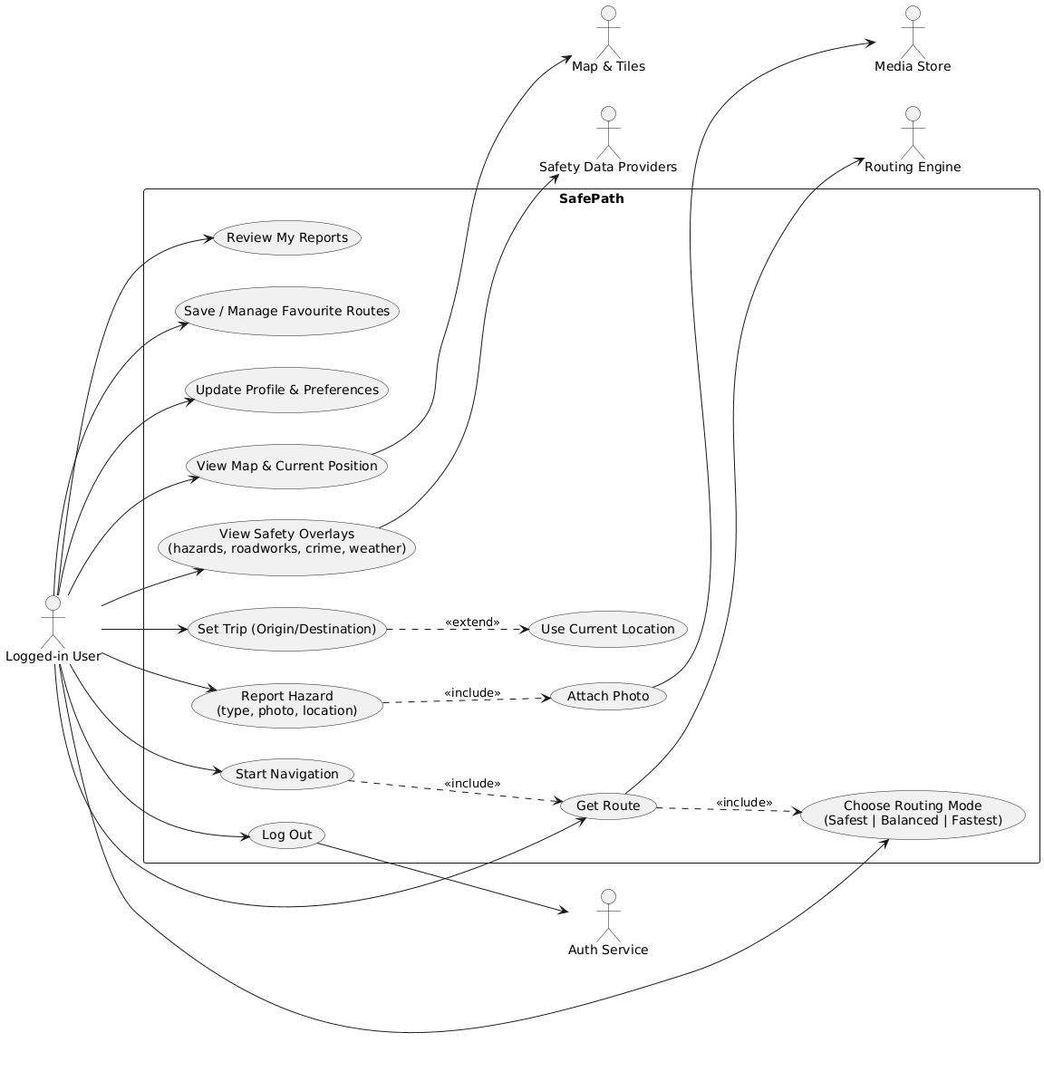

Figure 10 - SafePath High-level use-case diagram of MVP functionality

**Primary Actors**

* Logged-in User (cyclist/pedestrian)
* Supporting Actors (external systems)
* Routing Engine (OSRM/GraphHopper)
* Map & Tiles (OSM/tiles provider)
* Safety Data Providers (crime, roadworks, weather)
* Auth Service (JWT/session)
* Media Store (for hazard photos)
* Notification Service (optional MVP: email/in-app toast)

**Use Cases Overview**

* View Map & Current Position
* Set Trip (Origin/Destination)
* Choose Routing Mode (Safest / Balanced / Fastest)
* Get Route
* Start Navigation (basic turn hints + polyline)
* View Safety Overlays (nearby hazards, works, crime heat)
* Report Hazard (type, photo, location)
* Review My Reports (list, status)
* Save / Manage Favorite Routes
* Update Profile & Preferences (units, default mode, privacy)
* Log Out
* Get Route includes Choose Routing Mode
* Start Navigation includes Get Route
* View Safety Overlays includes data from Safety Data Providers
* Report Hazard includes Attach Photo (to Media Store)
* Set Trip extends Use Current Location (if chosen)

The following functionality will be included:

**Safety & Context Layers for Routes**

Mainstream map apps focus on travel time; SafePath expands this with safety layers (recent crime indicators, lighting coverage where available, roadworks, surface issues, weather). This mirrors how other products enrich maps with external signals e.g., Waze crowdsources live incident and hazard reports (potholes, construction, objects) that appear in navigation flows, a pattern SafePath adopts for community hazards(Report Road Hazards - Waze Help, n.d.).

**Personalized Route Recommendations Carousel**

SafePath suggests Safest / Balanced / Fastest routes and as per our survey data users prefer well-lit paths, inspired consumer platforms personalize choices using profiles/history. For cycling specific routing, CycleStreets (*CycleStreets » Help and Documentation*, n.d.) is a relevant analogue: it presents fastest, quietest, and a balanced option for each trip an approach SafePath generalizes with user safety preferences and time-of-day context.

To reflect where people actually ride (popularity/safety by presence), SafePath may consult aggregated activity patterns similar to Strava’s Global Heatmap, while carefully considering privacy lessons highlighted by prior heatmap differences(*Strava Metro and the Global Heatmap*, 2024).

**Tag Highlights & Badges on Route Cards**

Each route card surfaces the attributes most relevant to the user e.g., well-lit, protected lanes, low incident area, weather-friendly, community-verified safe. This communicates at-a-glance value much like listing or neighborhood products that present concise scores/badges; for instance, Walk Score popularized simple 0–100 neighborhood scores (Walk/Transit/Bike) to make context scannable an idea we adapt for route safety factors(*Walk Score Methodology*, n.d.).

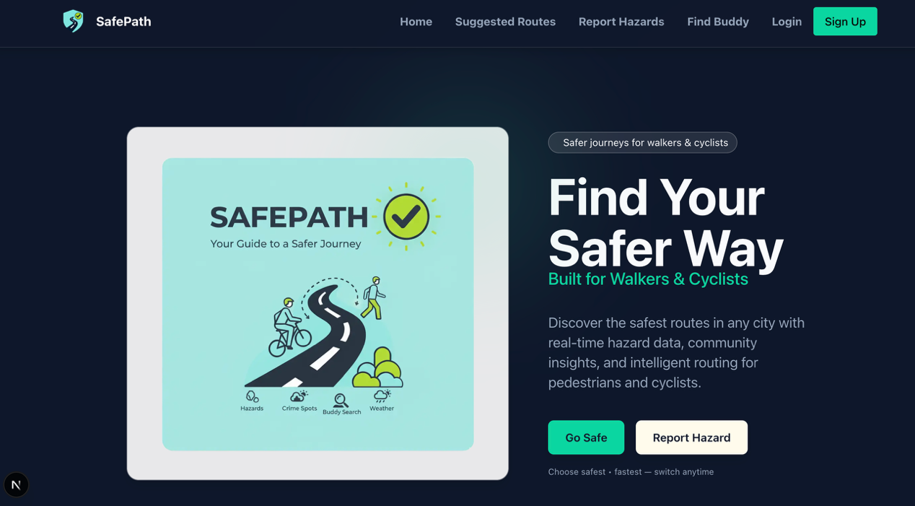

Figure 11- Homepage Desktop View

# **Technical Solution - The Plot**

**System Functionality**

Safepath is an all-in-one navigation system aimed at aiding pedestrians and cyclists in London with safety-optimized routing through the cooperation of numerous data sources as well as advanced algorithms. It works by merging crime rates from data.police.uk, infrastructure condition indicators from the National Cycle Network, traffic accident reports from the STATS19 system, and real-time user-reported hazards into a safety scoring system that produces customized routes depending on the user's tolerance for risk and the situation around him/her (Agarwal et al., 2024). This sophisticated solution has managed to overcome the most significant drawback of traditional navigation systems able to simply choose the fastest or shortest route but often compromising personal security, thus providing a very large urban navigation approach that offers safety along with practicality (Wang et al., 2021).

**System Architecture and Algorithm**

The Safepath system is built on a complex architectural structure that is capable of processing different types of safety data sources and thus generates routing decisions that are ready for action. A modified A* pathfinding algorithm is being used in the system to calculate the shortest path with safety scores being the edge weights, so it is possible to configure the risk tolerance settings for the trade-off of safety optimization and route efficiency (Delling et al., 2017). Moreover, the system uses kernel density estimation to extract crime hotspots from historical police data, computes the score of infrastructure quality depending on the presence of features like separated bicycle lanes and pedestrian crossings, and evaluates the danger of accidents with recent weighting of historical STATS19 data (Kang & Kang, 2017).

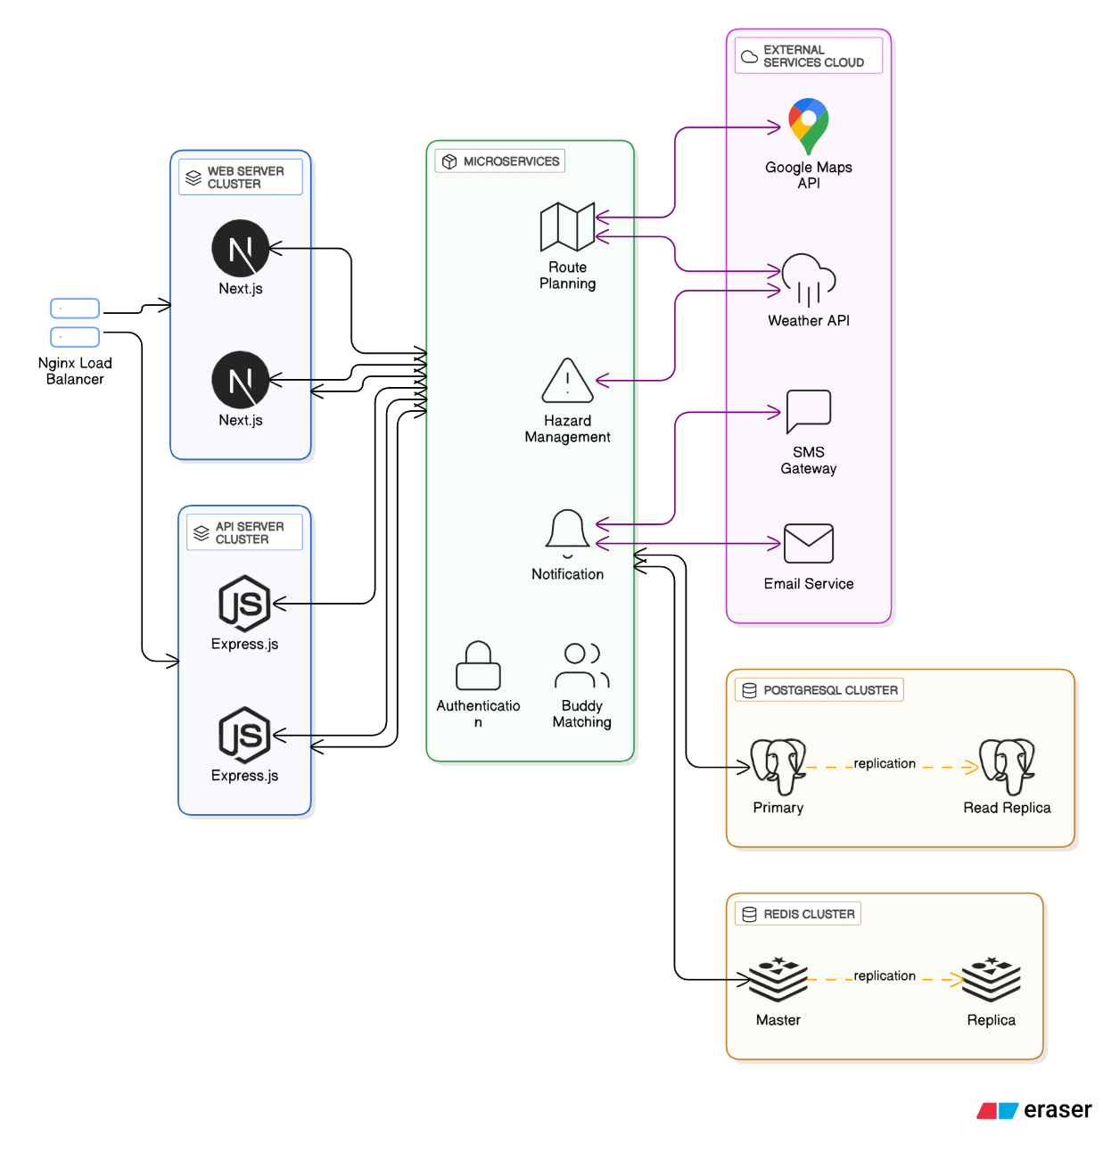

Figure 27 - Safepath System Architecture Diagram

**Note.** Detailed system architecture illustrating the complete technology stack, including load balancing, microservices architecture, database replication, caching layers, and external API integrations for comprehensive functionality.

The individual risk factors are weighted and summed up to arrive at a composite safety score where crime exposure contributes 30%, infrastructure quality 30%, collision risk 20%, and real-time hazard density 20% (Al-Omari et al., 2025). The routing algorithm subsequently provides several path alternatives through Yen's k-shortest paths algorithm, giving the users a selection of different routes that signify the varying trade-offs between safety and efficiency (Zhu, 2022).

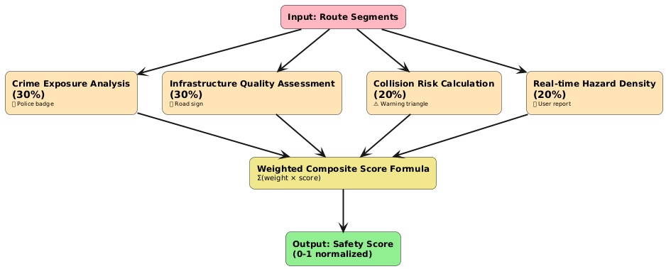

Figure 28 - Safety Scoring Algorithm Flowchart

***Note.*** Algorithm flowchart demonstrating how multiple safety factors are processed in parallel and combined using weighted percentages to generate a normalized composite safety score for each route segment.

## **Front-End Technologies**

Next.js 15 was utilized for the front-end implementation of the web application and a progressive web app (PWA) framework for mobile access which provided offline capabilities and push notifications. React components and Tailwind CSS were used to create the user interface which included an interactive map supported by Leaflet.js that showed route options with safety ratings represented by different colors (Quercia et al., 2014). Among the main interface parts were a route planning interface where safety preferences could be adjusted, a hazard reporting tool that allowed submission of photo and description, an emergency alert system that included live location sharing, and a travel buddy matching service that offered GPS tracking (Garg et al., 2025). To provide real-time updates and notifications, the system made use of WebSocket connections, thereby guaranteeing that users are instantly informed about the newly reported hazards using the latest updated data where it is updated monthly that are in their vicinity.

### Figure 3.3: *User Interface Mockup: Route Planning Screen*



Route planning interface allowing users to input destinations and configure safety preferences. The slider enables personalization of the safety-efficiency trade-off based on individual risk tolerance.

### Figure 3.4: *User Interface Mockup: Interactive Map with Routes*



 Interactive map interface displaying multiple route alternatives with visual safety indicators. Hazard markers show real-time reported issues, and the comparison table enables informed decision-making.

### Figure 3.5: *User Interface Mockup: Hazard Reporting Interface*



Hazard reporting interface will make users to contribute real-time safety information. Photo upload, categorization, and severity rating ensure structured data collection for system-wide safety assessments.

### Figure 3.6: *User Interface Mockup: Emergency Alert Screen*



Emergency alert interface prioritizing rapid access to emergency services. Live location sharing and automatic contact notification provide critical safety features for vulnerable road users in distress.

## **Back-End Architecture**

The back-end architecture includes a microservices-based system that is deployed on a highly available clustered infrastructure with load balancing. The API gateway is built using Express.js and it consists of authentication middleware, request validation, and rate limiting in its structure. The business logic is spread across different services according to their specialization, such as a Route Planning Service that performs pathfinding algorithms and safety score calculations, a Hazard Management Service that verifies and processes user reports, a Buddy Matching Service that manages location-based pairing requests, and a Notification Service that oversees push notifications, emails, and SMS alerts (Kumar et al., 2024). All these microservices are talking to each other via internal APIs and event-driven architecture, and Redis is utilized as a cache layer for active sessions storage and often accesses route data.



Figure 29 - Database Entity-Relationship Diagram

Note. Database schema using crow's foot notation to illustrate relationships. PostGIS geometry fields enable spatial queries for proximity analysis and route calculation.

# **Evaluation**

**Success Criteria**

The Safepath system is successful only when it produces routes that are significantly safer than those generated by the traditional distance-based routing. Furthermore, its practical usability and user acceptance have to be confirmed through trials done in urban areas within United Kingdom. The system sets a target of 15% as the minimum safety score improvement of the composite type compared to the conventional algorithms, recording the significance level of p < 0.05 and a medium or larger effect size (Cohen's d ≥ 0.5) in the paired-sample hypothesis testing (Sohrabi & Lord, 2022).

Meanwhile, user satisfaction is another area where success is measured since users may not necessarily be the ones to pay for using the system. Therefore, the system is expected to be rated at least 5.0 out of 7 in terms of consumer satisfaction and through regular users who would be the users of the system (Wang et al., 2021). Besides, the final evaluation will be done based on the merging of many safety factors into one routing framework, the successful adaptation of routes according to individual risk taking, and the dependable reporting of hazards with automatic alerts to the users in the vicinity (Kim et al., 2023).

## **Evaluation Methodology**

The evaluation methodology consists of an extensive statistical testing framework that is based on a user experiment with 15 participants who are chosen to reflect the target population of pedestrians and cyclists in United Kingdom. In the course of the study, the participants will evaluate the same origin-destination pairs through both conventional navigation (control) and Safepath (experimental) systems, which will allow within-subjects comparison and will control for individual route preferences (Pahlavani & Delavar, 2014). Every participant has to answer a demographic questionnaire, assess six route pairs, give safety perception ratings using a 7-point Likert scale, rank route preferences, and take part in a semi-structured interview that is meant to collect qualitative feedback (Telima et al., 2023).

### Figure 4.1: *User Study Protocol Flowchart*

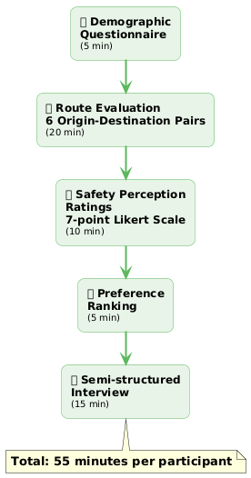

Structured protocol ensuring systematic data collection. The within-subjects design controls for individual preferences while allowing statistical comparison between conventional and safety-optimized routing.

The composite safety score is the main evaluation metric and it is a normalized metric from 0 to 1 that combines crime exposure (incidents per km), infrastructure quality (average segment score), and collision risk probability per route (Al-Omari et al., 2025). To show the trade-off between safety and convenience (Delling et al., 2017), efficiency metrics are the route distance in meters, estimated travel time in minutes, and efficiency ratio (time_proposed/time_conventional). User acceptance metrics consist of perceived safety, willingness to use, preference ranking, and System Usability Scale (SUS) used for system usability.

### Figure 4.2*: Evaluation Metrics Dashboard Mockup*

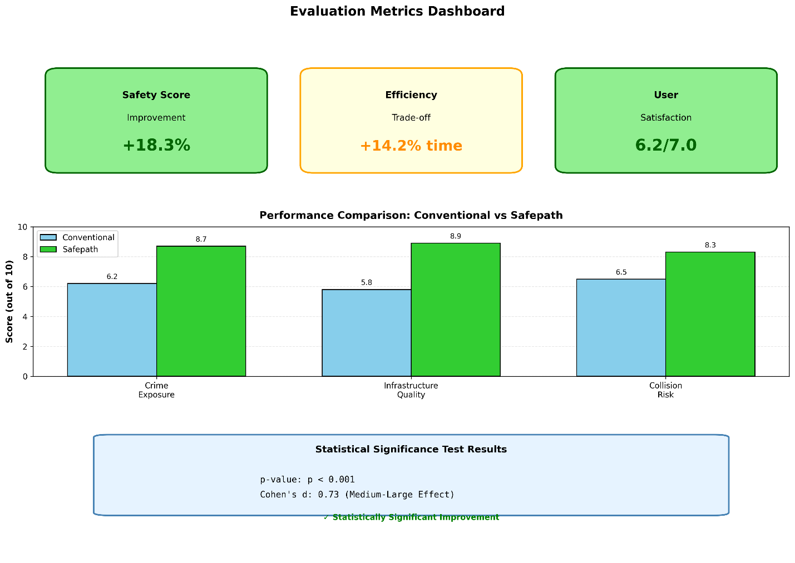Example dashboard illustrating key evaluation metrics. Green indicators show positive outcomes, while the medium-large effect size demonstrates practical significance beyond statistical significance.

### Figure 4.3: *Route Comparison Example*

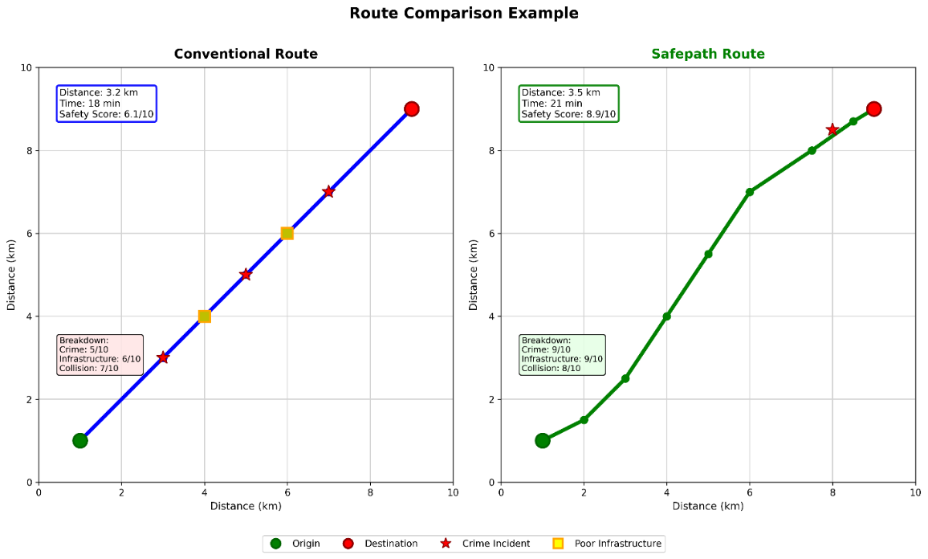

Real-world route comparison demonstrating Safepath's safety optimization. The 9% distance increase yields a 46% safety score improvement, illustrating the practical benefits of multi-factor route planning.

# **Conclusion**

## **Project Management Strategy**

The Safepath project management plan is based on a structured, milestone-driven strategy with phases and deliverables clearly defined throughout a 14-week period. The methodology mixes Agile development and traditional project management to some extent, thus enabling iterative progress while still being answerable to major milestones (Marshall & Ferenchak, 2019). The entire project is spread out into seven iterations of two weeks each, with each iteration being dedicated a certain task: weeks 1-2 for data collection and API configuration, weeks 3-4 for data merging and processing, weeks 5-6 for safety factor modeling, weeks 7-8 for development of machine learning, weeks 9-10 for routing algorithm application, weeks 11-12 for user study conducting, and weeks 13-14 for statistical analysis and final report preparation.

**Figure 5.1:** 14-Week Project Timeline (Gantt Chart)

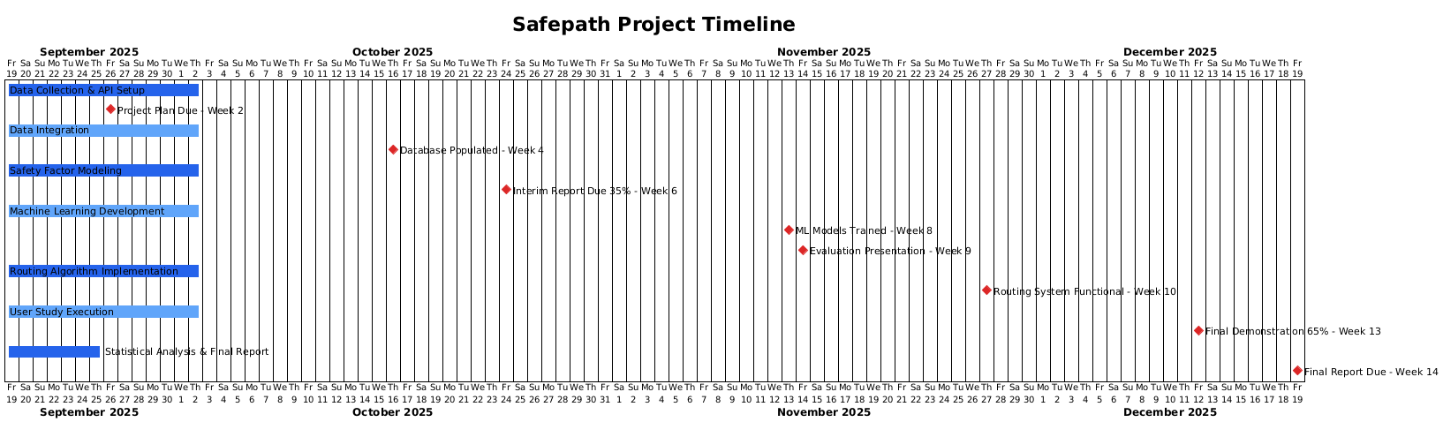

Note. Project timeline with seven two-week sprints aligned Project schedule (September 19 - December 19, 2025). Milestone markers indicate critical deliverables including project plan submission, database population, interim report (35%), operational pipeline, trained ML models, functional routing system, final demonstration (65%), and completed final report.

The phased method guarantees orderly advancement and at the same time it gives room to deal with the technical problems in the moment that they arise (Delling et al., 2017). The timeline incorporates regular assessments of progress, and specific milestones that include project plan submission by week finalized population with initial datasets by week 2, interim report and demonstration by week 6, an operational integrated data pipeline by week 4, validated safety scoring algorithms by week 6, trained and evaluated machine learning models by week 8, a functional routing system by week 10, completed user study data collection by week 12, final demonstration by week 13, and finalized statistical analysis and final report by week 14.

**Figure 5.2:** Milestone Dependencies Network

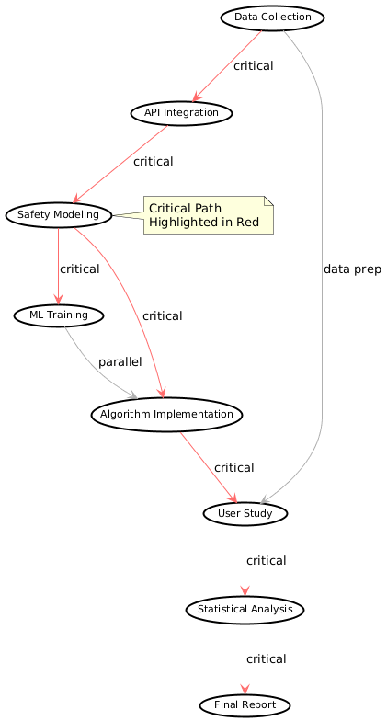

Note. Network diagram illustrating dependencies between major project milestones. The critical path (red) identifies activities that directly impact project completion, while parallel activities optimize resource utilization.

## **Current Challenges**

At present, the most significant problems that the project is encountering are the complexity of data integration, the optimization of real-time performance, and the recruitment of users for the study. Heterogeneous data sources from 43 UK police departments, Transport for London, OpenStreetMap, and user surveys form the basis of the research, and the data normalization, spatial alignment, and temporal consistency are the areas that face the most significant challenges (Novack et al., 2024). The real-time route calculation that needs to be performed with sub-second response times while safety scores processing across thousands of route segments is going to require sophisticated algorithm optimization and caching strategies (Zhang et al., 2019).

Figure 5.3: Risk Management Matrix

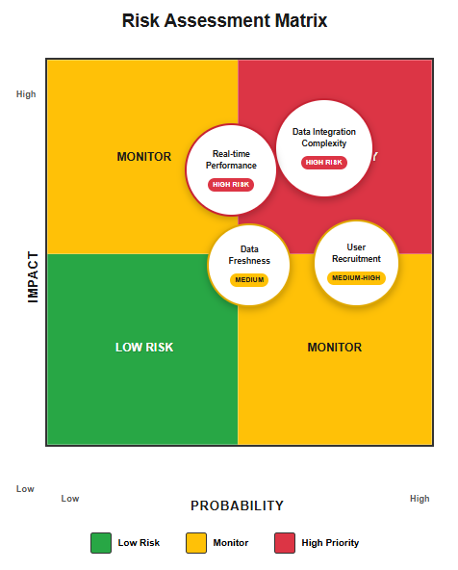

***Note.*** Risk assessment matrix prioritizing project challenges. High-impact, high-probability risks (red quadrant) receive immediate attention, while lower-priority risks are monitored throughout the project lifecycle.

User study recruitment that is representative of the target user groups, i.e. pedestrians and cyclists of different age groups, genders and experience levels, is quite challenging logistically, especially when it comes to getting a big enough sample for valid statistical results (Sohrabi & Lord, 2022). Moreover, having data up-to-date and at the same time conducting monthly updates from numerous sources need strong automated pipelines that can tackle data quality problems and format changes (Kang & Kang, 2017).

## **Timeline and Deliverables**

For successful results with the remaining time, the project will give priority to the realization of the essential technical parts and at the same time, it will impose strict evaluation standards. The author will first develop the data integration pipeline and safety scoring algorithms, then proceed with the work on the modified A* routing algorithm with safety heuristics (Al-Omari et al., 2025). At the same time, the user study recruitment will start with outreach to cycling advocacy groups, university mailing lists, and social media platforms, aiming for a diverse pool of participants (Wang et al., 2016).

The remaining timeline gives a space for comprehensive testing and improvement of every part separately before putting all of them together, with special focus on performance enhancement and user interface usability (Quercia et al., 2014). Continuous progress evaluations will keep the project on track with the milestone plan, and the last few days are reserved for technical issues that were not anticipated. This project management style, together with the constant focus on the important tasks, will result in the delivery of a complete safety routing system that has undergone thorough assessment and that achieves the research goals (Zhu, 2022).

# **References and Key Resources**

1. Agarwal, K., Srivastava, A., Sharma, K., Satapathy, S. K., Cho, S. B., Mishra, S., & Pal, A. (2024). SafeRoutes: Charting a secure path—A holistic approach to women's safety through advanced clustering and GPS integration. *IEEE Access, 12,* 167824–167841. <https://doi.org/10.1109/ACCESS.2024.3488784>
2. Al-Omari, A., Alsaleh, M., & Shatnawi, N. (2025). Spatial-temporal analysis and severity prediction of traffic accidents. *Engineered Science, 34,* Article 1472. <http://dx.doi.org/10.30919/es1472>
3. Bennett, D. L. (2017). Bumps and bicycles: Women's experience of cycle-commuting during pregnancy. *Journal of Transport & Health, 6,* 439–451. <https://doi.org/10.1016/j.jth.2017.02.003>
4. Branion-Calles, M., Nelson, T., & Winters, M. (2017). Comparing crowdsourced near-miss and collision cycling data and official bike safety reporting. *Transportation Research Record, 2662(1),* 1–11. <https://doi.org/10.3141/2662-01>
5. CycleStreets. (n.d.). *Help and documentation.* Retrieved October 23, 2025, from <https://www.cyclestreets.net/help/journey/routing/>
6. Delling, D., Goldberg, A. V., Pajor, T., & Werneck, R. F. (2017). Customizable route planning in road networks. *Transportation Science, 51(2),* 566–591. <https://doi.org/10.1287/trsc.2014.0579>
7. Department for Transport. (2024). *Reported road casualties Great Britain: Pedestrian factsheet, 2024.* GOV.UK. <https://www.gov.uk/government/statistics>
8. Department for Transport. (2025). *Reported road casualties Great Britain: Road user risk 2024.* GOV.UK. <https://www.gov.uk/government/statistics/reported-road-casualties-great-britain-road-user-risk-2024>
9. Garg, S., Mittal, A., & Sathiyasuntharam, V. (2025). Deep learning based model to recommend safe route navigation system. In *2025 2nd International Conference on Computational Intelligence, Communication Technology and Networking (CICTN)* (pp. 181–186). IEEE. <https://doi.org/10.1109/CICTN64563.2025.10932570>
10. Google Play. (n.d.). *Citymapper.* Retrieved from https://play.google.com/store/apps/details?id=com.citymapper
11. Kang, H. W., & Kang, H. B. (2017). Prediction of crime occurrence from multi-modal data using deep learning. *PLoS One, 12(4),* Article e0176244. <https://doi.org/10.1371/journal.pone.0176244>
12. Kapousizis, G., Goodman, A., & Aldred, R. (2021). Cycling injury risk in Britain: A case-crossover study of infrastructural and route environment correlates. *Accident Analysis & Prevention, 154,* Article 106063. <https://doi.org/10.1016/j.aap.2021.106063>
13. Kim, D., Baek, J., Yang, J., Roh, H., Jeong, H., Ruiz, B., & Matson, E. T. (2023, July). Safe route recommendation based on crime risk prediction with urban and crime data. In *2023 IEEE Ninth International Conference on Big Data Computing Service and Applications (BigDataService)* (pp. 111–118). IEEE. <https://doi.org/10.1109/BigDataService58306.2023.00022>
14. Kumar, A., Maurya, A., Kumar, P., Gupta, A., & Saini, J. (2024, December). Optimizing safe routes with machine learning: A crime prediction system for urban safety. In *2024 International Conference on Emerging Technologies and Innovation for Sustainability (EmergIN)* (pp. 368–372). IEEE. <https://doi.org/10.1109/EmergIN63207.2024.10961735>
15. Marshall, W. E., & Ferenchak, N. N. (2019). Why cities with high bicycling rates are safer for all road users. *Journal of Transport & Health, 13,* Article 100539. <https://doi.org/10.1016/j.jth.2019.03.004>
16. Myhrmann, M. S., & Mabit, S. E. (2023). Assessing bicycle crash risks controlling for detailed exposure: A Copenhagen case study. *Accident Analysis & Prevention, 192,* 107226. <https://doi.org/10.1016/j.aap.2023.107226>
17. Nelson, T. A., Denouden, T., Jestico, B., Laberee, K., & Winters, M. (2015). BikeMaps.org: A global tool for collision and near miss mapping. *Frontiers in Public Health, 3.* <https://doi.org/10.3389/fpubh.2015.00053>
18. Novack, T., Vorbeck, L., & Zipf, A. (2024). An investigation of the temporality of OpenStreetMap data contribution activities. *Geo-spatial Information Science, 27(2),* 259–275. <https://doi.org/10.1080/10095020.2022.2124127>
19. Pahlavani, P., & Delavar, M. R. (2014). Multi-criteria route planning based on a driver’s preferences in multi-criteria route selection. *Transportation Research Part C: Emerging Technologies, 40,* 14–35. <https://doi.org/10.1016/j.trc.2014.01.001>
20. Pazdan, S. (2020). The impact of weather on bicycle risk exposure. *Archives of Transport, 56(4),* 89–105. <https://doi.org/10.5604/01.3001.0014.5629>
21. Portus, S. (2024, July 24). *Best cycling apps 2025 | 19 iPhone and Android apps for cyclists.* *BikeRadar.* <https://www.bikeradar.com/advice/buyers-guides/best-cycling-apps>
22. Quercia, D., Schifanella, R., & Aiello, L. M. (2014). The shortest path to happiness: Recommending beautiful, quiet, and happy routes in the city. In *Proceedings of the 25th ACM Conference on Hypertext and Social Media* (pp. 116–125). ACM. <https://doi.org/10.1145/2631775.2631799>
23. Reynolds, C. C., Harris, M. A., Teschke, K., Cripton, P. A., & Winters, M. (2009). The impact of transportation infrastructure on bicycling injuries and crashes: A review of the literature. *Environmental Health, 8,* 47. <https://doi.org/10.1186/1476-069X-8-47>
24. Sohrabi, S., & Lord, D. (2022). Navigating to safety: Necessity, requirements, and barriers to considering safety in route finding. *Transportation Research Part C: Emerging Technologies, 137,* Article 103542. <https://doi.org/10.1016/j.trc.2021.103542>
25. Strava. (2024, July 31). *Strava Metro and the global heatmap.* <https://support.strava.com/hc/en-us/articles/216918877-Strava-Metro-and-the-Global-Heatmap>
26. Telima, M., El Esawey, M., El-Basyouny, K., & Osama, A. (2023). The use of crowdsourcing data for analyzing pedestrian safety in urban areas. *Ain Shams Engineering Journal, 14(6),* Article 102140. <https://doi.org/10.1016/j.asej.2023.102140>
27. Teschke, K., Harris, M. A., Reynolds, C. C. O., Winters, M., Babul, S., Chipman, M., Cusimano, M. D., Brubacher, J. R., Hunte, G., Friedman, S. M., Monro, M., Shen, H., Vernich, L., & Cripton, P. A. (2012). Route infrastructure and the risk of injuries to bicyclists: A case-crossover study. *American Journal of Public Health, 102(12),* 2336–2343. <https://doi.org/10.2105/AJPH.2012.300762>
28. Transport for London. (2024). *New statistics show lowest number of people killed on London’s roads outside of pandemic years.* <https://tfl.gov.uk/info-for/media/press-releases/2024>
29. UK Police. (2025). *Data downloads: Street-level crime, outcome, and stop and search data.* <https://data.police.uk/data/>
30. Utriainen, R., O'Hern, S., & Pöllänen, M. (2023). Review on single-bicycle crashes in the recent scientific literature. *Transport Reviews, 43(2),* 159–177. <https://doi.org/10.1080/01441647.2022.2055674>
31. Vidal-Tortosa, E., & Lovelace, R. (2024). Road lighting and cycling: A review of the academic literature and policy guidelines. *Journal of Cycling and Micromobility Research, 2,* 100008. <https://doi.org/10.1016/j.jcmr.2023.100008>
32. Walk Score. (n.d.). *Walk Score methodology.* Retrieved October 23, 2025, from <https://www.walkscore.com/methodology.shtml>
33. Wang, R., Zhou, M., Gao, K., Alabdulwahab, A., & Rawa, M. J. (2021). Personalized route planning system based on driver preference. *Sensors, 22(1),* Article 11. <https://doi.org/10.3390/s22010011>
34. Wang, Y., Chau, C. K., Ng, W. Y., & Leung, T. M. (2016). A review on the effects of physical built environment attributes on enhancing walking and cycling activity levels within residential neighborhoods. *Cities, 50,* 1–15. <https://doi.org/10.1016/j.cities.2015.08.004>
35. Zhang, Y., Cheng, T., & Ren, Y. (2019). A graph deep learning method for short-term traffic forecasting on large road networks. *Computer-Aided Civil and Infrastructure Engineering, 34(10),* 877–896. <https://doi.org/10.1111/mice.12450>
36. Zhu, S. (2022). Multi-objective route planning problem for cycle-tourists. *Transportation Letters, 14(3),* 298–306. <https://doi.org/10.1080/19427867.2020.1860355>